RAVES DASHBOARD

Manual

Table of Contents
Introduction 3
Managing a course 4
Adding a course 5
Course Setting 7
Adding Participants to Course 9
Adding activities to your course 10
Adding a file or folder to the course 11
Adding and embedded a PDF file to your course 11
Adding and embedding Youtube Video to your course 13
Adding quiz to your course 15
Create Quiz 18
True/False Question 19
Multiple Choice Question 19
Grade Book Set Up 22
Add a new category 22
Mark a manual grade item 24
Deleting a course 26
User Manual 28
Your profile 28
Your notifications and messages 29
Your courses 29
Submitting an assignment 30

Introduction

KUWAKA Learning Management System (LMS) is a software designed to help trainers create quality online courses and manage learner outcomes.

Access the dashboard

Type in www.ravesdashboard.org on your browser to access the dashboard.
Only home page, documents which are marked public and about us section are visible on the screen.
Authenticated users can further login by clicking on login button on top right corner.

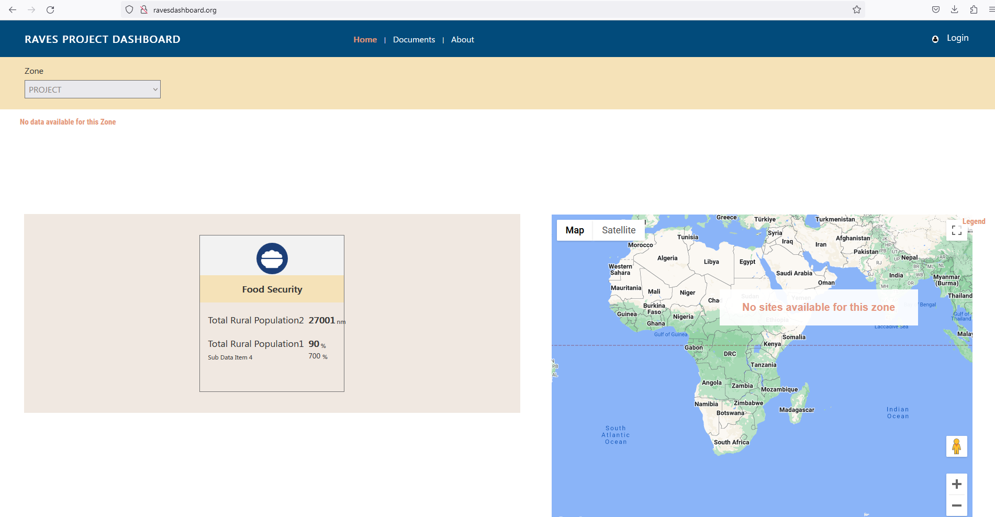

Enter relevant details (Username and Password) for login

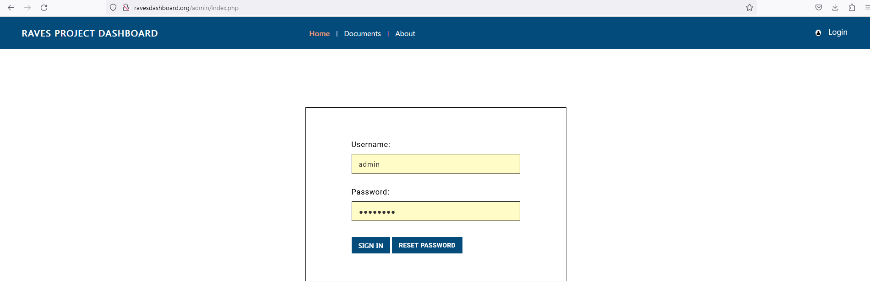

Once log in the header navigation panel will give you further access to other pages as per permissions given by admin.

User Management
Authorised roles can create users, and manage their roles and permissions.

Add New user
Step 1: Click on ‘Setup’ page from header
Step 2: Click on users from left side menu bar
Step 3: Click on add user to create new user
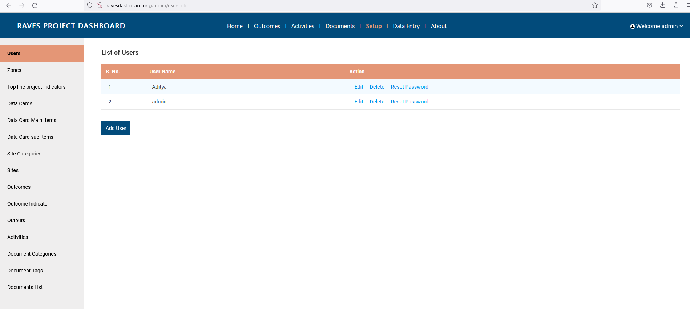

Step 4: Fill in the form and assign relevant rights to users.
Step 5: Click on Save to proceed
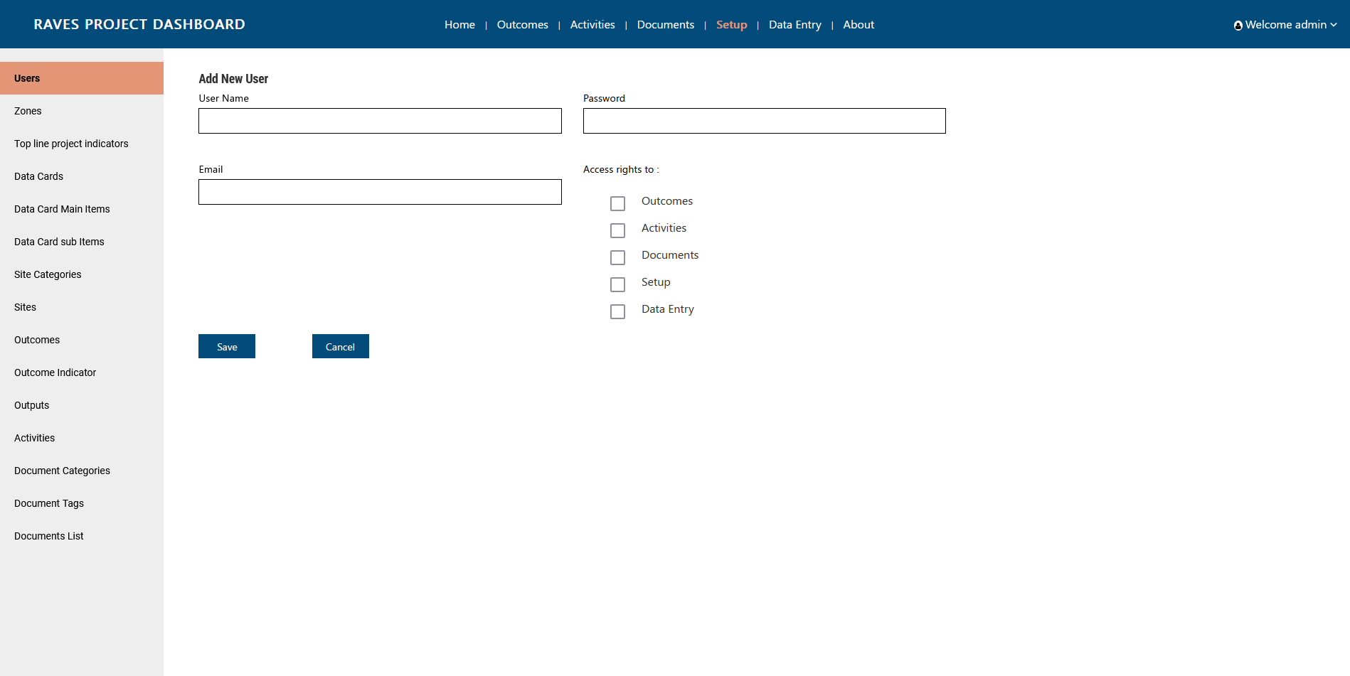

Edit user details
Step 1: Click on ‘Setup’ page from header
Step 2: Click on users from left side menu bar
Step 3: Click on Edit button against the user one wish to edit

Step 4: Edit the necessary details
Step 5: Click on update to proceed
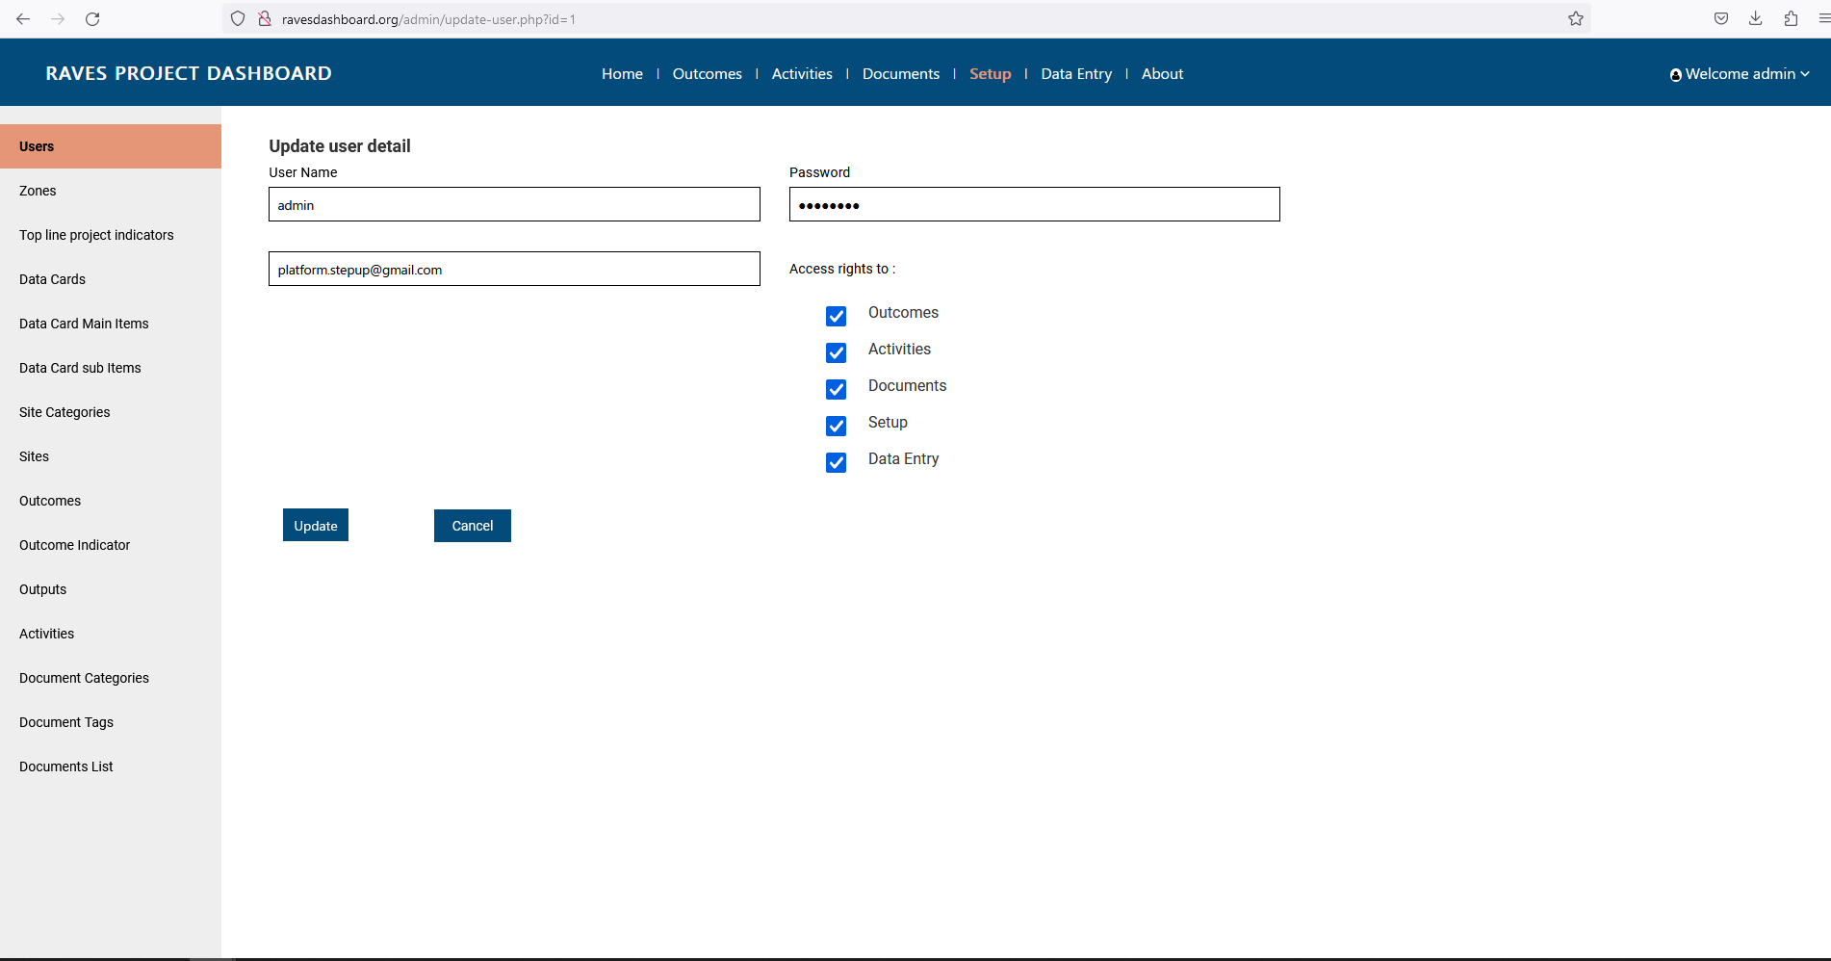

Zones Management

Add zone
Step 1: Click on ‘Setup’ page from header
Step 2: Click on Zones from left side menu bar
Step 3: Click on Add Zones button
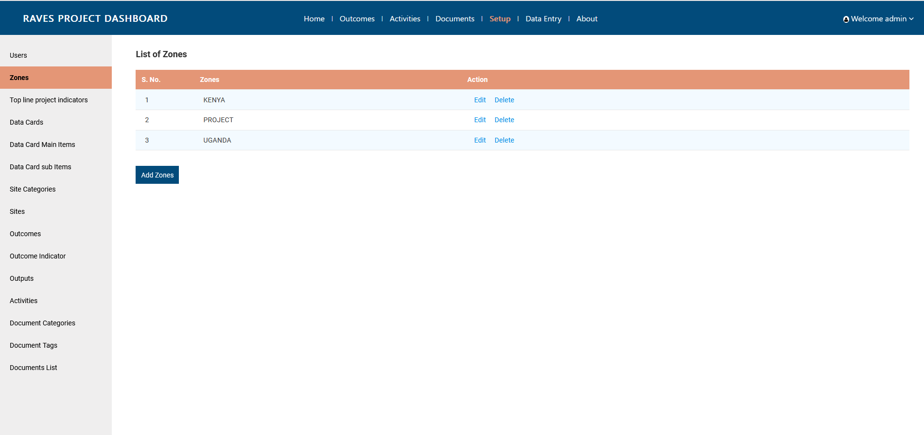

Step 4: Add zone name
Step 5: Click on Submit to proceed
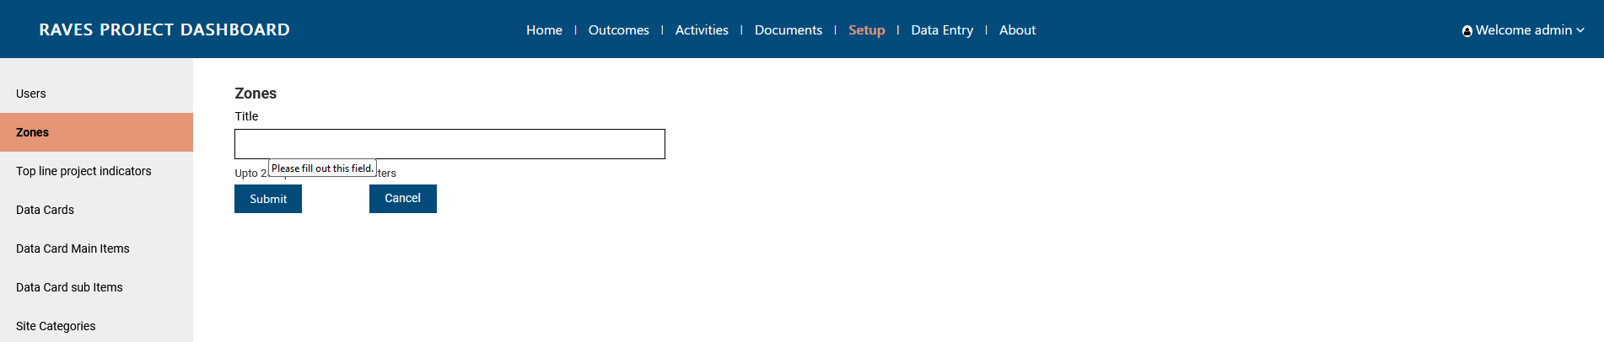

Edit Zone
Step 1: Click on ‘Setup’ page from header
Step 2: Click on Zones from left side menu bar
Step 3: Click on Edit button against the Zone one needs to edit

Step 4: Edit zone name
Step 5: Click on Update to proceed
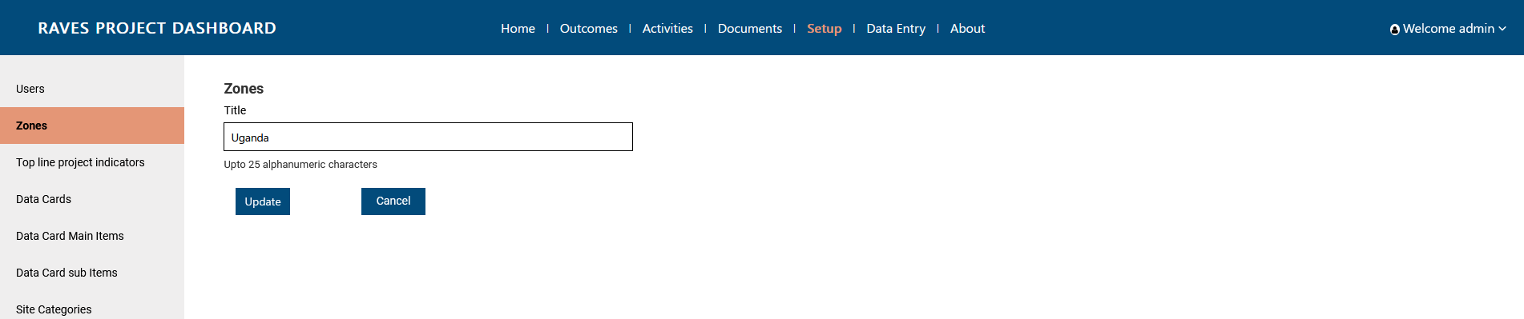

Top Line Indicator Management

Add zone
Step 1: Click on ‘Setup’ page from header
Step 2: Click on Top line project indicator from left side menu bar
Step 3: Click on Add Indicator button
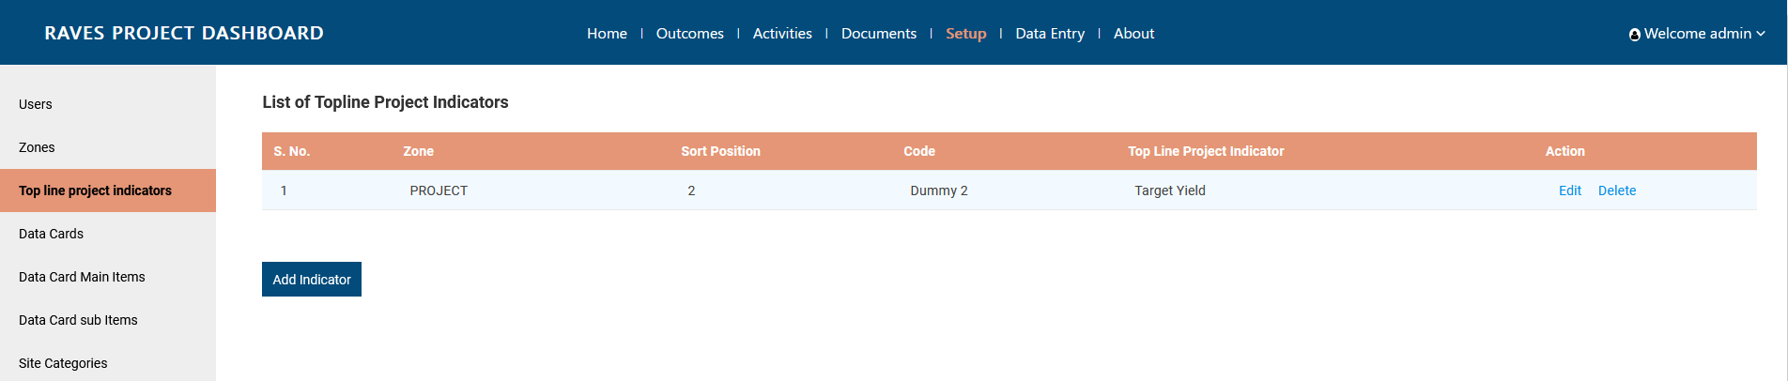

Step 4: Fill in the details. Code has to be unique. Sort position will decide the position in front end page from left to right.
Step 5: Click on Submit to proceed
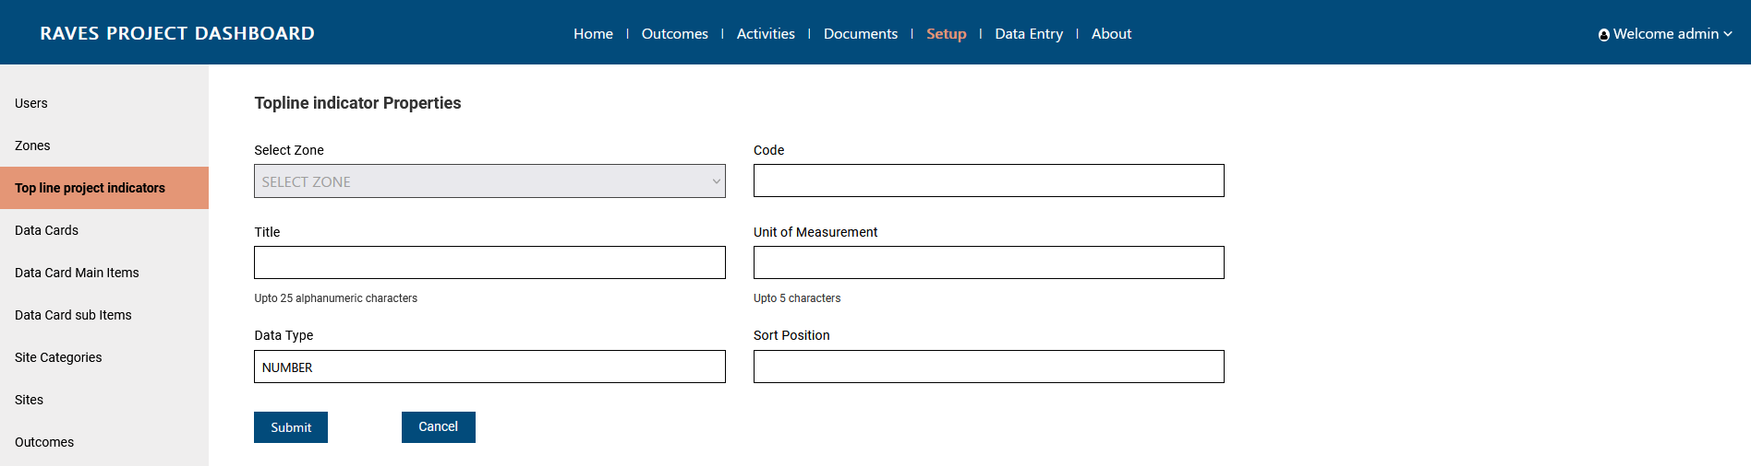

Edit Top line project indicator
Step 1: Click on ‘Setup’ page from header
Step 2: Click on Top line project indictor from left side menu bar
Step 3: Click on Edit button against the Top line project indictor one needs to edit

Step 4: Edit details as needed. Do note that changing zone would not be possible.
Step 5: Click on Update to proceed
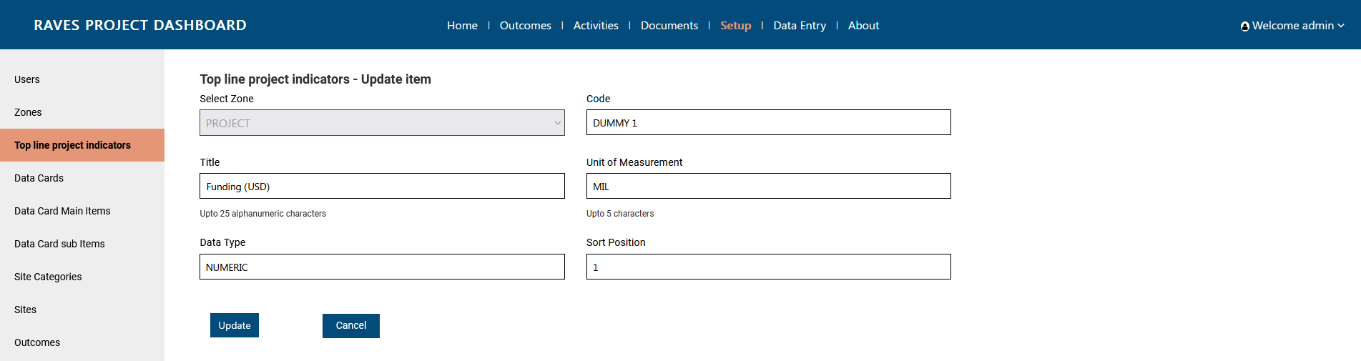

Add Top line project indicator values
Step 1: Click on ‘Data entry’ page from header
Step 2: Click on Top line indictors from left side menu bar
Step 3: Click on Add Topline Indicator Value

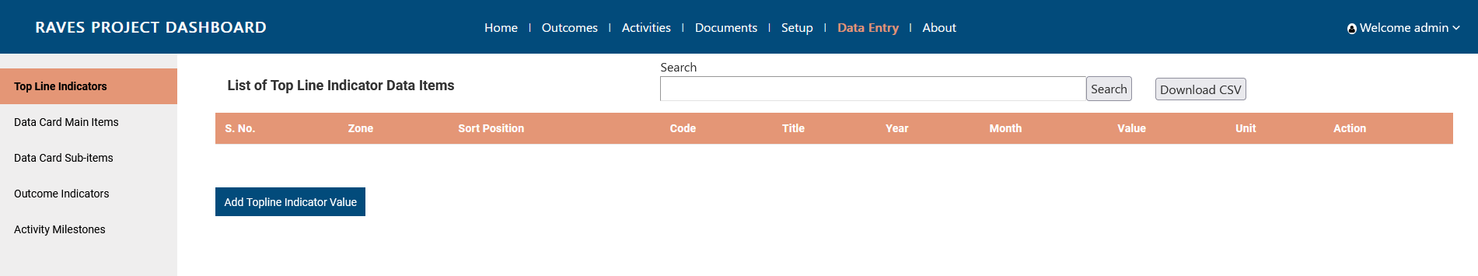
Step 4: Fill in the details. Select Zone first to activate the Title dropdown. Enter the 4 digits year along with the month from dropdown, and add the value. Unit cannot be changed from here. It would be default as per the detailed entered in Set Up section.
Step 5: Click on submit to proceed.
Note: For adding new value for another period, add a new data entry.
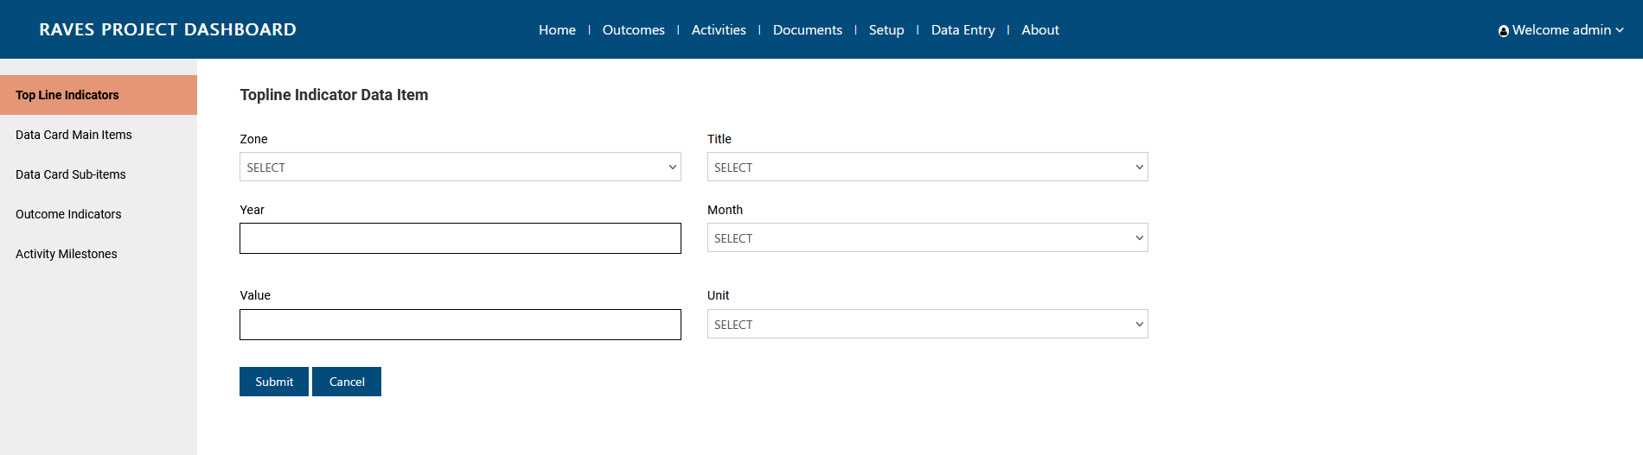

Edit Top line project indicator values
Step 1: Click on ‘Data entry’ page from header
Step 2: Click on Top line indictors from left side menu bar
Step 3: Click on Edit Topline Indicator Value 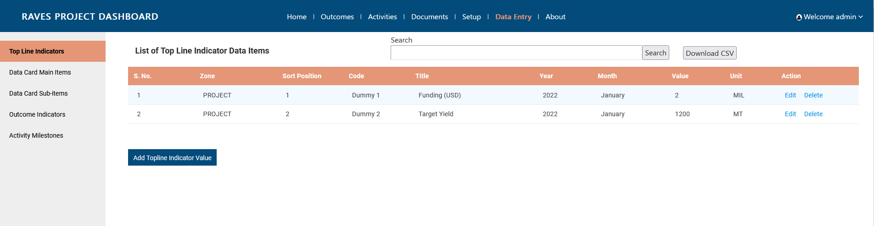
Step 4: Edit details. One can edit year, month and value
Step 5: Click on update to proceed.
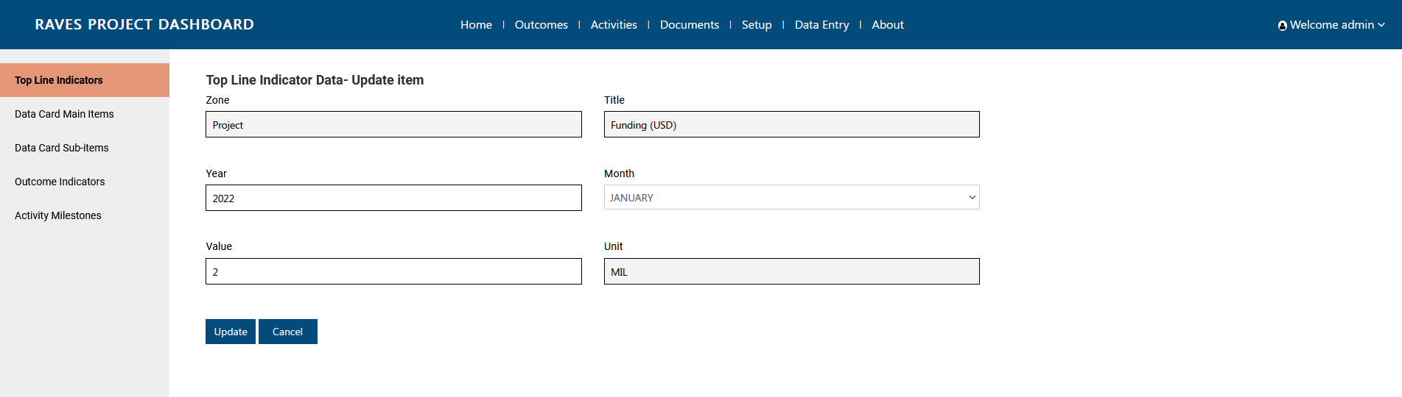

Data Cards Management
Data cards are divided into three forms, one for creating a new data card, followed with Data card main item and data card sub item Data card main item and subitem values can be updated

Add Data cards
Step 1: Click on ‘Setup’ page from header
Step 2: Click on Data cards from left side menu bar
Step 3: Click on Add Data Card button
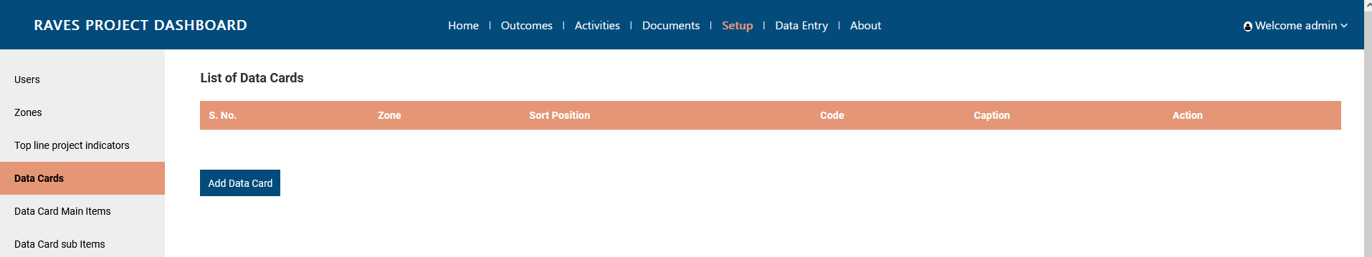

Step 4: Fill in the details. Code has to be unique as per project. Sort position will decide the position in front end page. Icon has to be 75px x 75 px, in Transparent PNG.
Step 5: Click on Submit to proceed
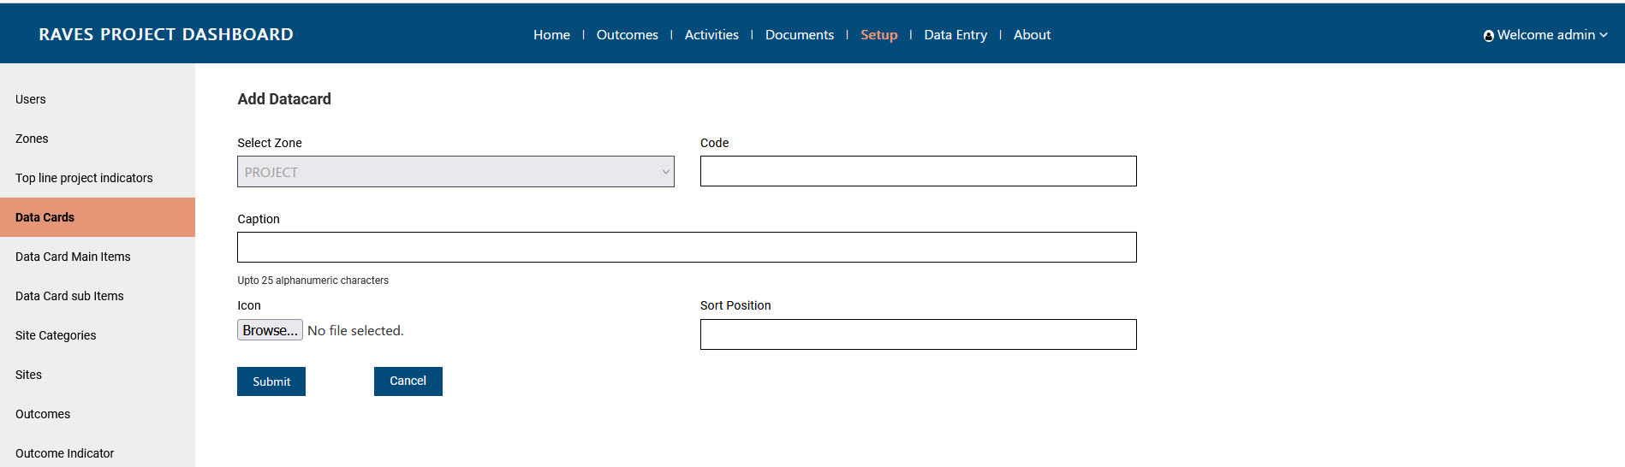

Edit Data cards
Step 1: Click on ‘Setup’ page from header
Step 2: Click on Data cards from left side menu bar
Step 3: Click on Edit button against the data card
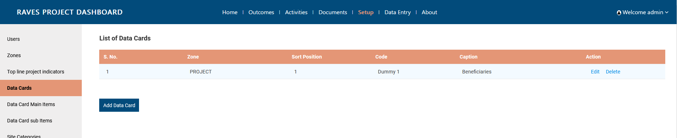

Step 4: Edit details. One cannot edit Zone.
Step 5: Click on Update to proceed
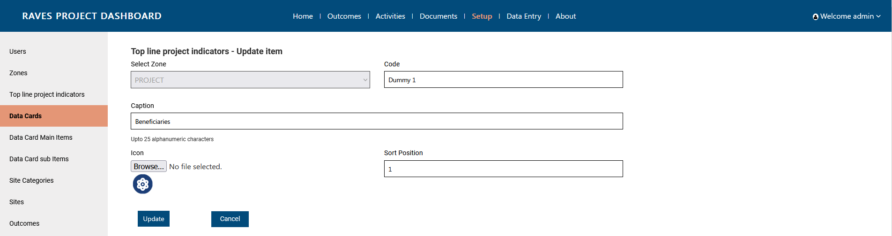

Add Data cards Main item
Step 1: Click on ‘Setup’ page from header
Step 2: Click on Data cards main item from left side menu bar
Step 3: Click on Add Data Card Main Item button
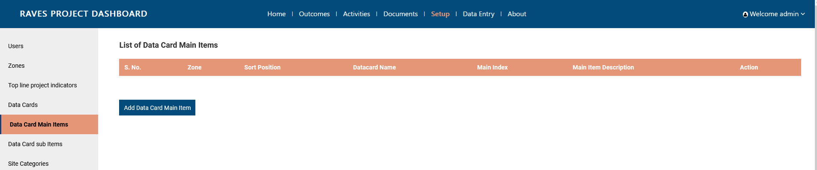

Step 4: Fill in the details. On selecting the zone, data card dropdown would get activated. Main item index has to be unique as per Data card.
Step 5: Click on Submit to proceed
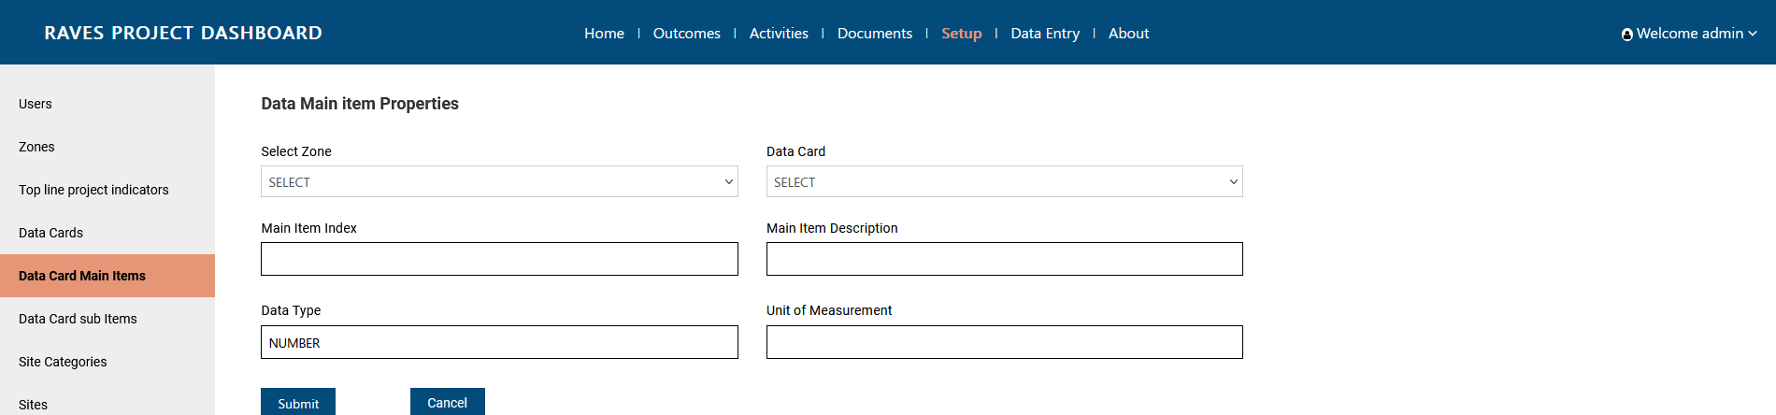

Edit Data cards Main item
Step 1: Click on ‘Setup’ page from header
Step 2: Click on Data cards main item from left side menu bar
Step 3: Click on Edit button against the Data Card Main Item
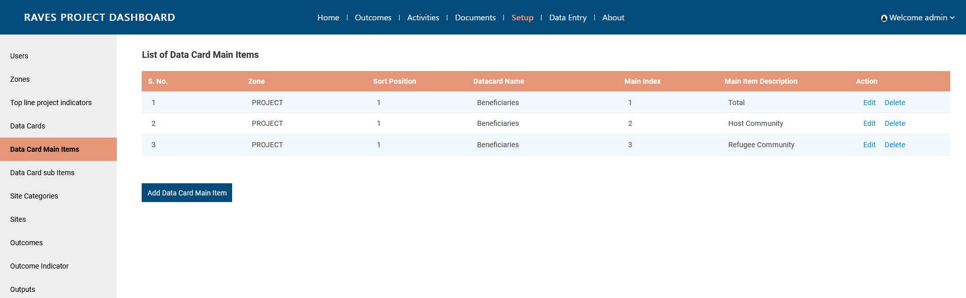

Step 4: Edit in the necessary details.
Step 5: Click on Update to proceed
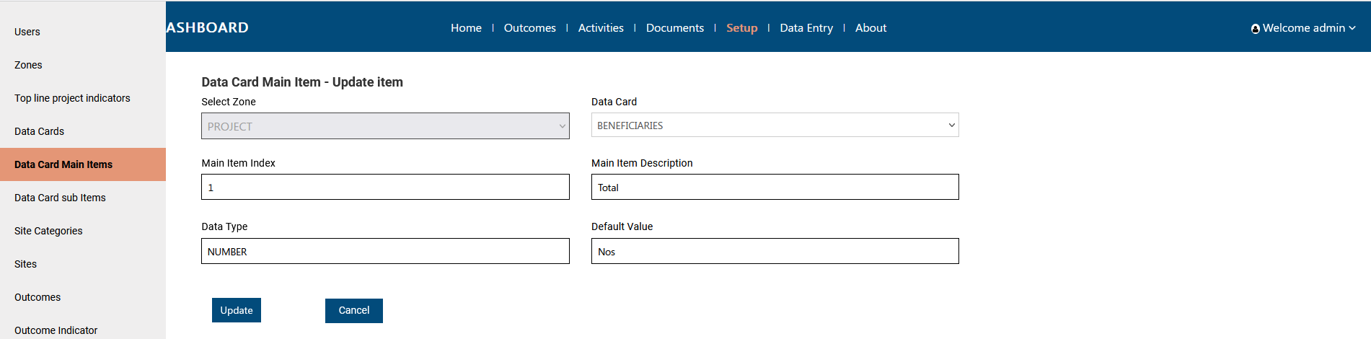

Add Data cards sub item
Step 1: Click on ‘Setup’ page from header
Step 2: Click on Data cards Sub Item from left side menu bar
Step 3: Click on Add Data Card Sub Item button
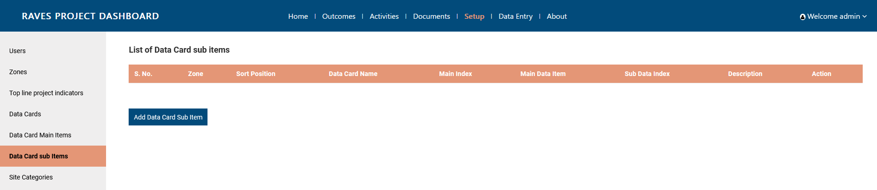

Step 4: Fill in the details. On selecting the zone, data card dropdown would get activated. On selecting Data Card, Main data item would get activated. Sub-data item index has to be unique per Main data item.
Step 5: Click on Submit to proceed
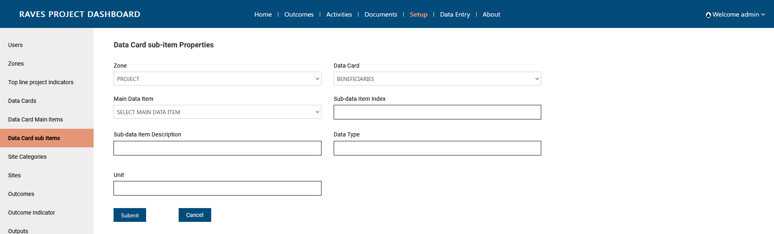

Adding Values to Data Card Main Item
Step 1: Click on ‘Data entry’ page from header
Step 2: Click on Data Card Main Item from left side menu bar
Step 3: Click on Add Data Card Main Item Value

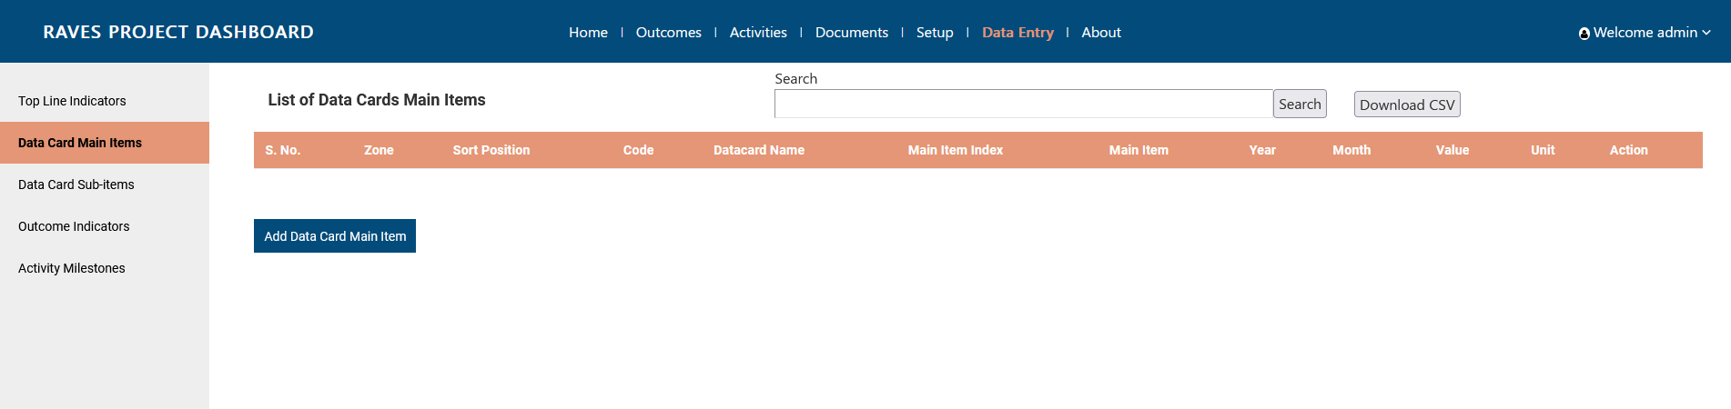
Step 4: Fill in the details. Select Zone first to activate the Title dropdown. Select title to durther activate the Main data item dropdown. Enter the 4 digits year along with the month from dropdown, and add the value. Unit cannot be changed from here. It would be default as per the detailed entered in Set Up section.
Step 5: Click on submit to proceed.
Note: For adding new value for another period, add a new data entry.
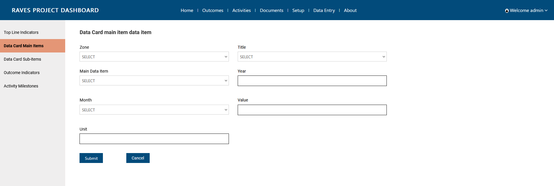

Edit Data Card Main item values
Step 1: Click on ‘Data entry’ page from header
Step 2: Click on Data Card Main Item from left side menu bar
Step 3: Click on Edit button against the Data Card Main Item
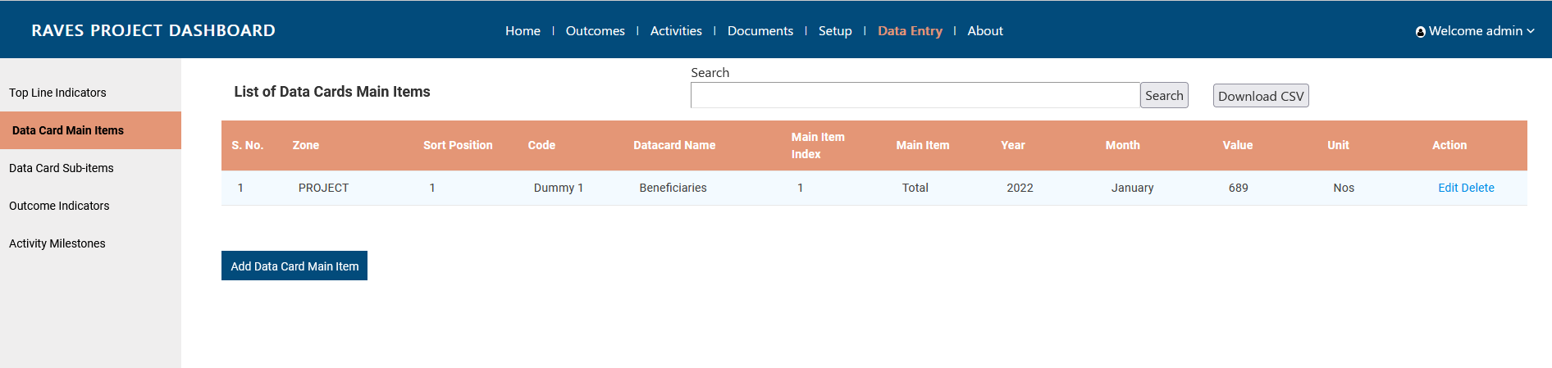
Step 4: Edit details. One can edit year, month and value
Step 5: Click on update to proceed.
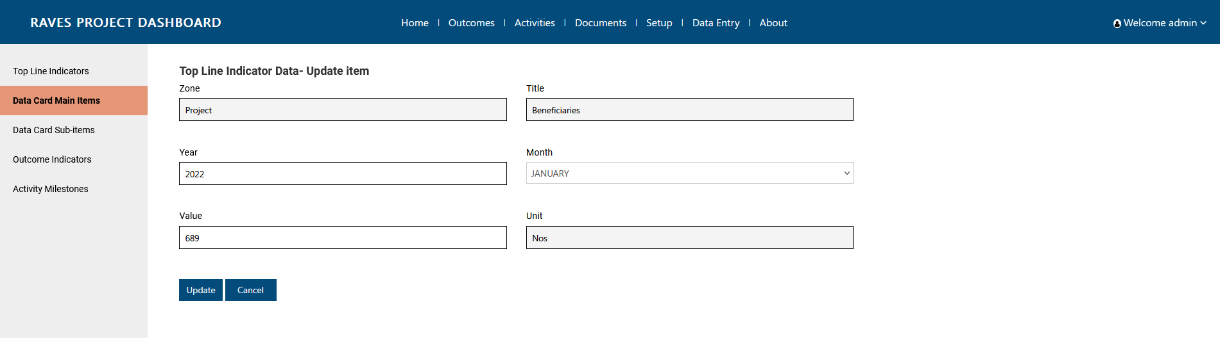

Adding Values to Data Card Sub Item
Step 1: Click on ‘Data entry’ page from header
Step 2: Click on Data Card Sub Item from left side menu bar
Step 3: Click on Add Data Card Sub Item Value

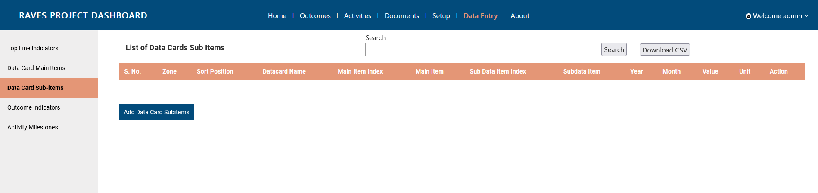
Step 4: Fill in the details. Select Zone first to activate the Title dropdown. Select title to further activate the Main data item dropdown. Select Main data item dropdown to activate Sub item dropdown. Enter the 4 digits year along with the month from dropdown, and add the value. Unit cannot be changed from here. It would be default as per the detailed entered in Set Up section.
Step 5: Click on submit to proceed.
Note: For adding new value for another period, add a new data entry.
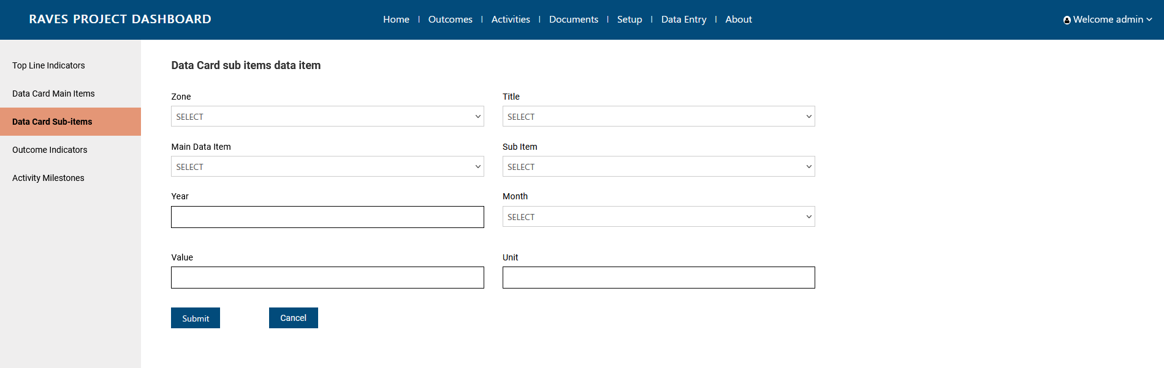

Edit Data Card Sub item values
Step 1: Click on ‘Data entry’ page from header
Step 2: Click on Data Card Sub Item from left side menu bar
Step 3: Click on Edit button against the Data Card Sub Item
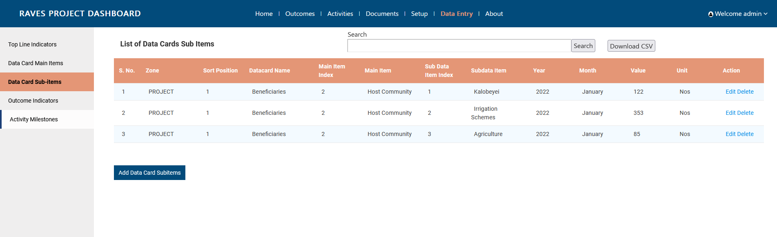
Step 4: Edit details. One can edit year, month and value
Step 5: Click on update to proceed.
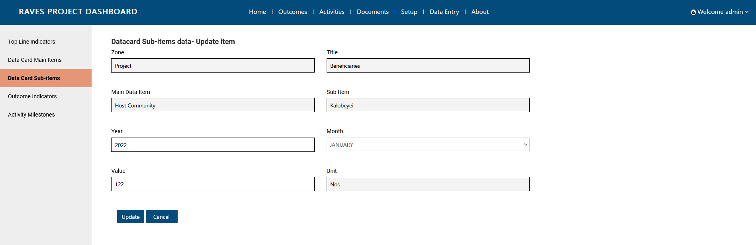

Site Management
Before adding a site, add site categories.

Add Site Category
Step 1: Click on ‘Data entry’ page from header
Step 2: Click on Site Categories from left side menu bar
Step 3: Click on Add Site Category
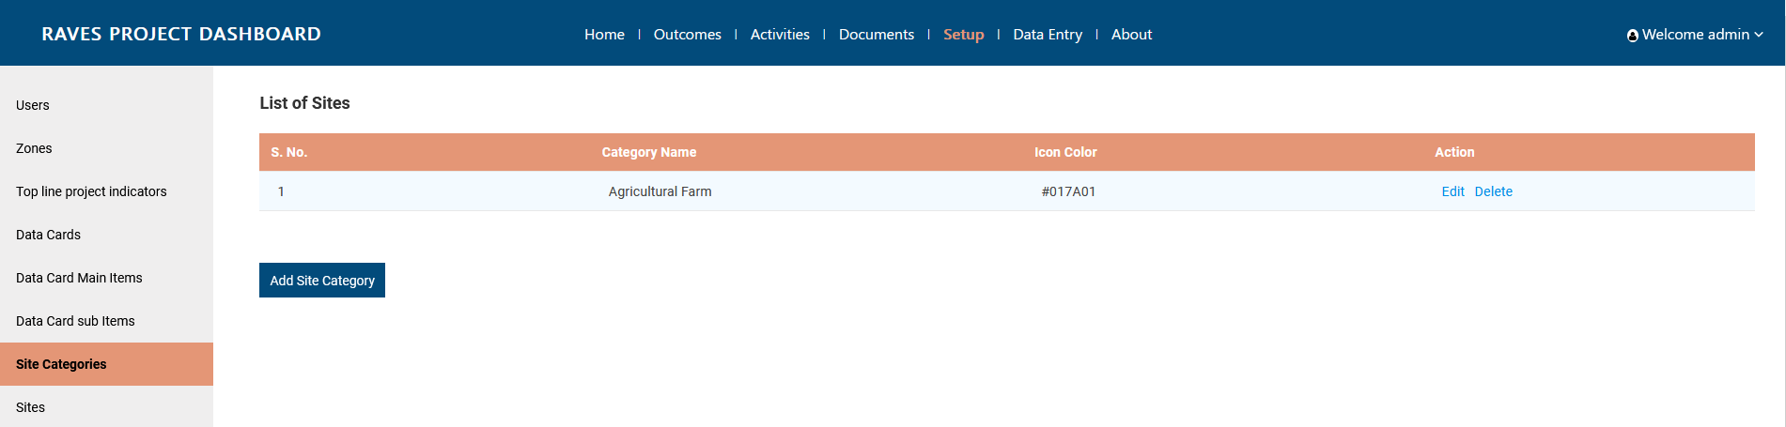
Step 4: Fill in the details.
Step 5: Click on Submit to proceed

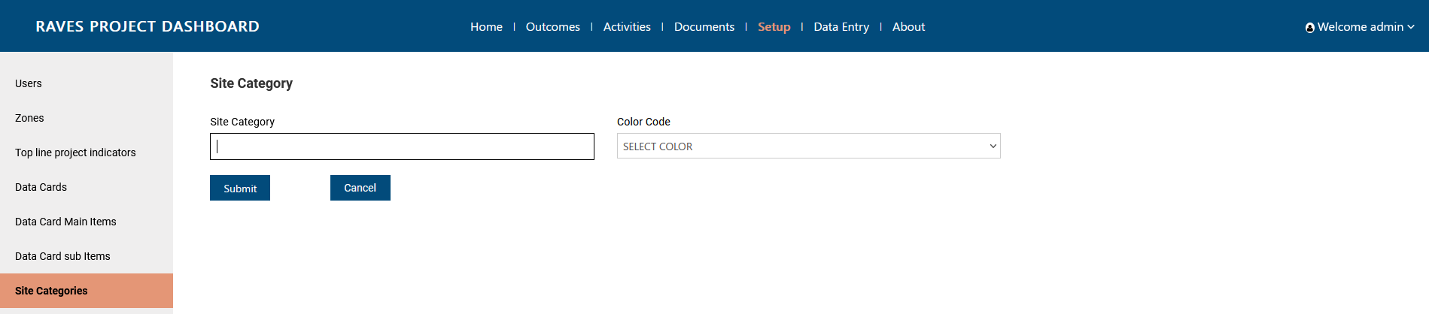

Edit Site category
Step 1: Click on ‘Data entry’ page from header
Step 2: Click on Site Categories from left side menu bar
Step 3: Click on Edit button against Site Category
Step 4: Edit the details.
Step 5: Click on update to proceed

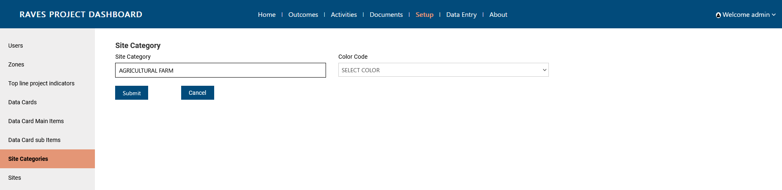

Add new site
Step 1: Click on ‘Data entry’ page from header
Step 2: Click on Site from left side menu bar
Step 3: Click on Add Site
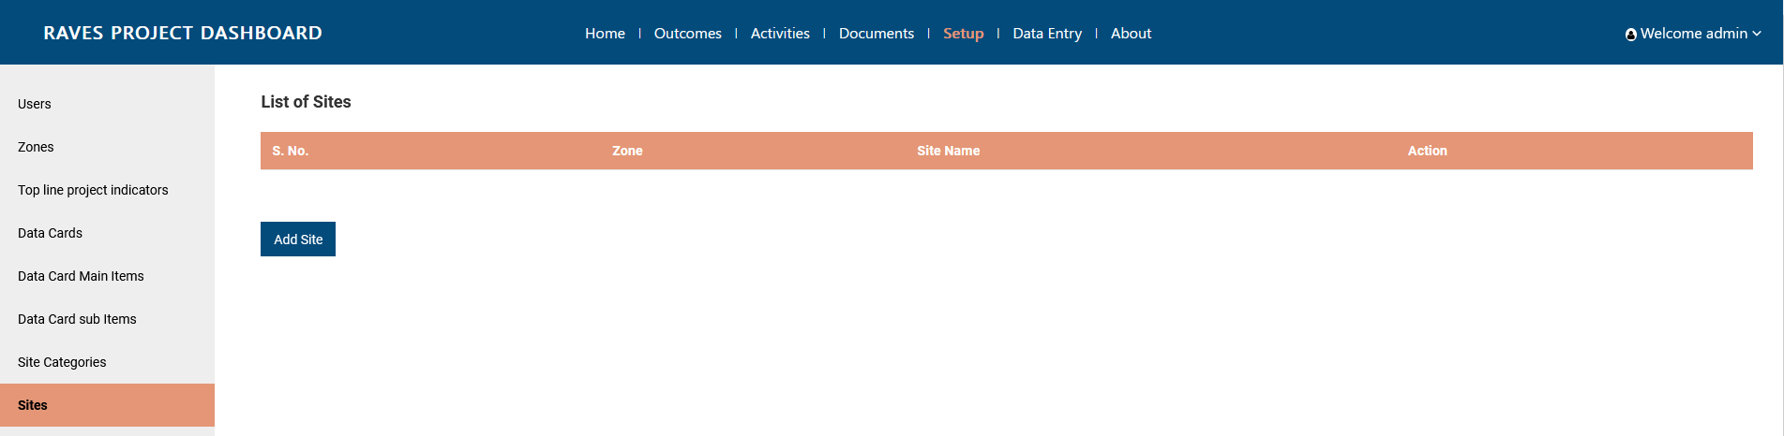
Step 4: Fill in the details.
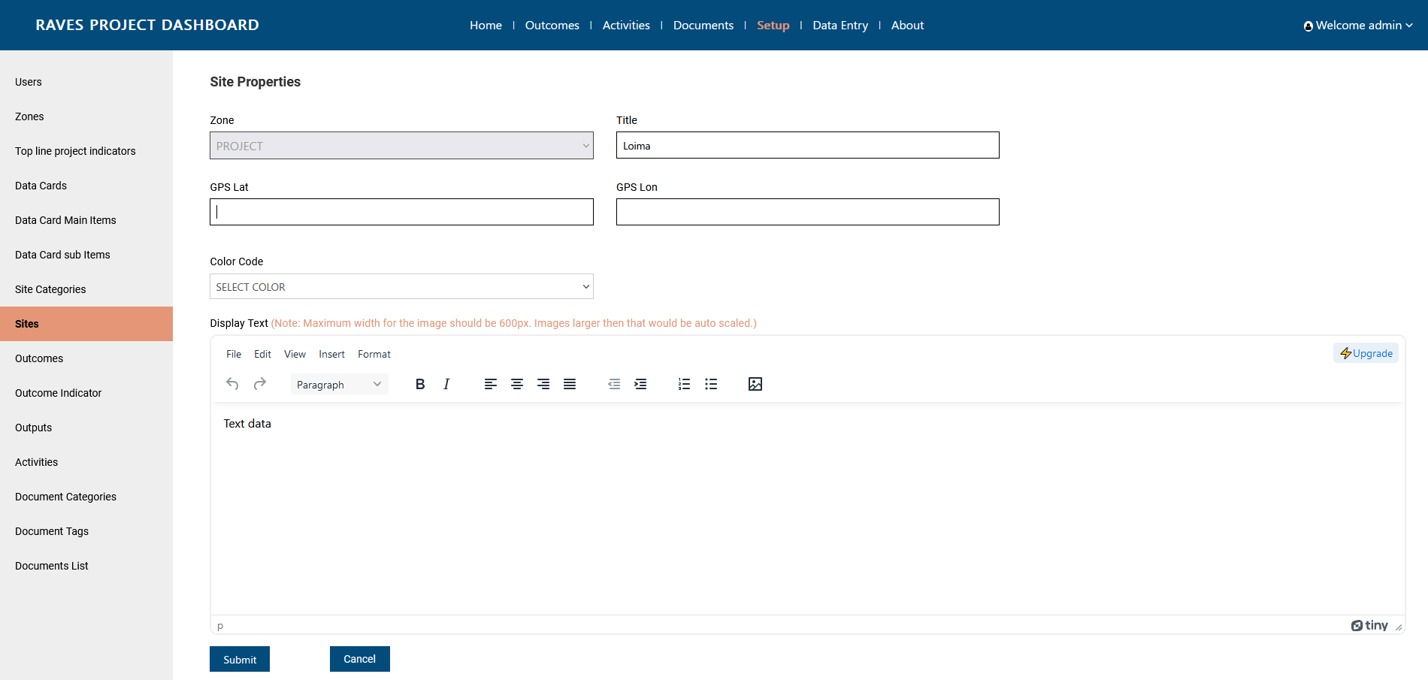
Step 5: To add an image, click on the image icon inside the TinyMC RTF box.
Step 6: Click on Upload in the pop up window
Step 7: Browse the image and click on save
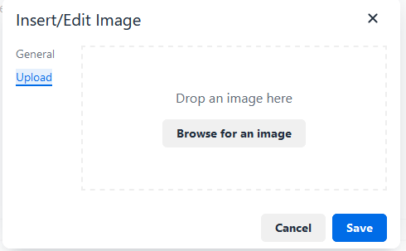
Do note: Image width shouldn’t exceed 600px.
Step 8: Click on Submit to proceed.
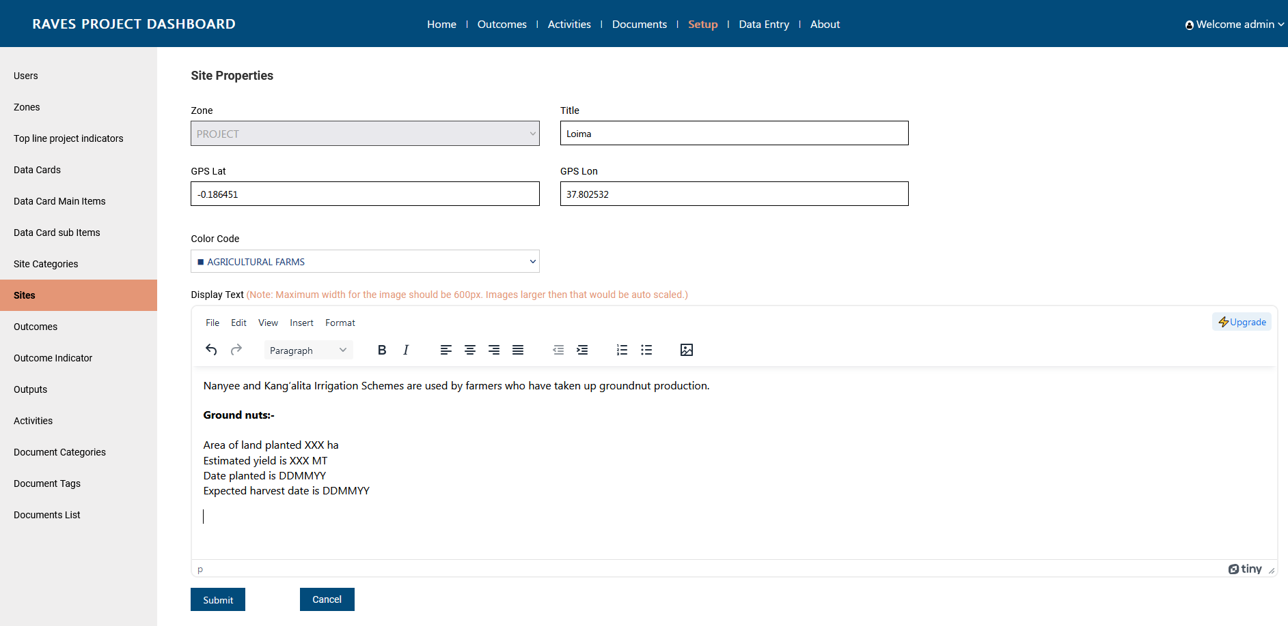

Edit site
Step 1: Click on ‘Data entry’ page from header
Step 2: Click on Site from left side menu bar
Step 3: Click on Edit button against the site
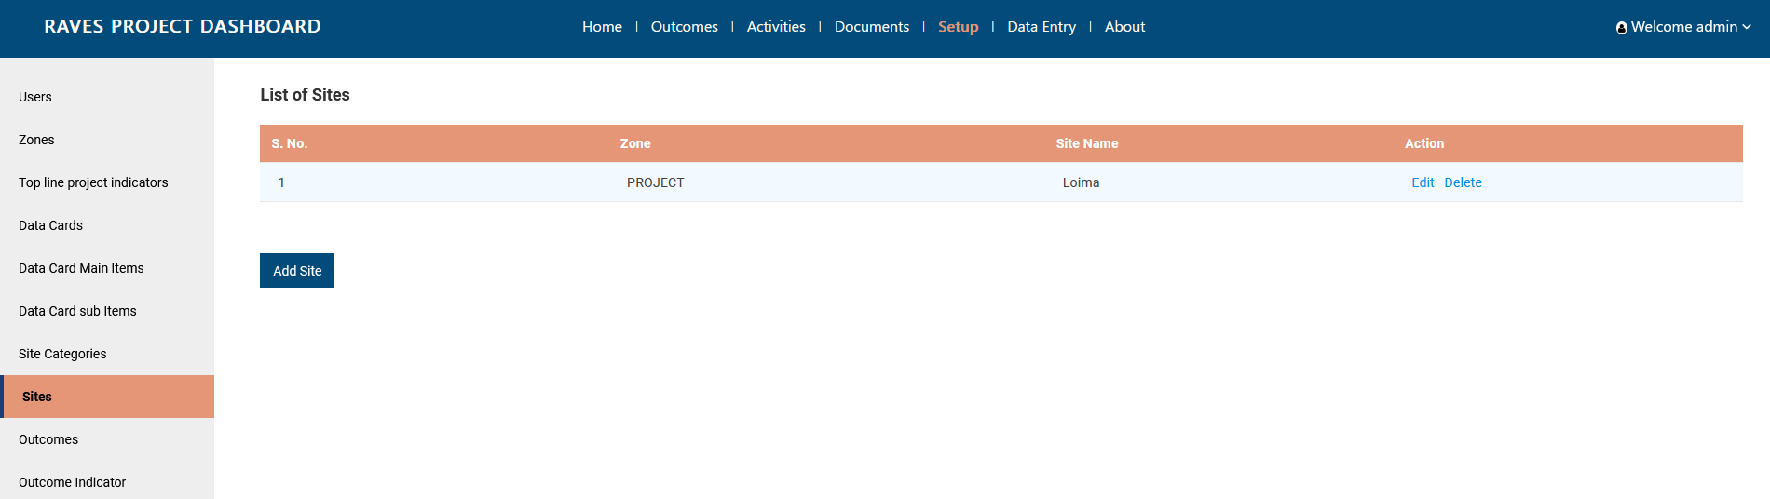
Step 4: Edit details
Step 5: Click on Update to proceed

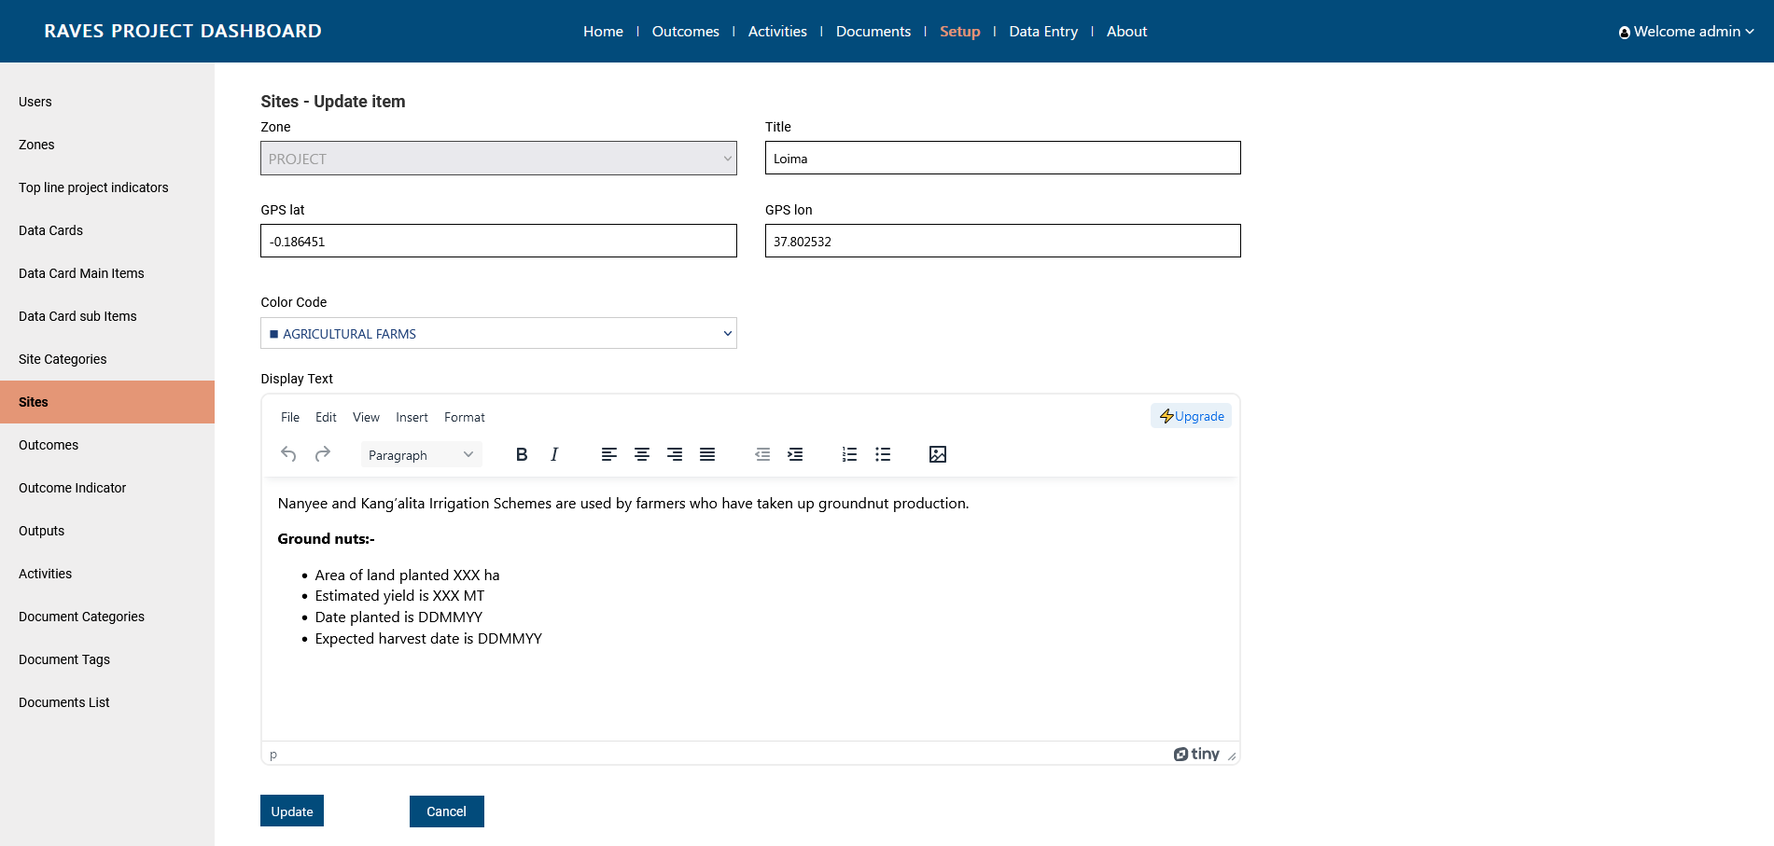

Outcomes Management

Add Outcome
Step 1: Click on ‘Setup’ page from header
Step 2: Click on Outcome from left side menu bar
Step 3: Click on Add Outcome button .
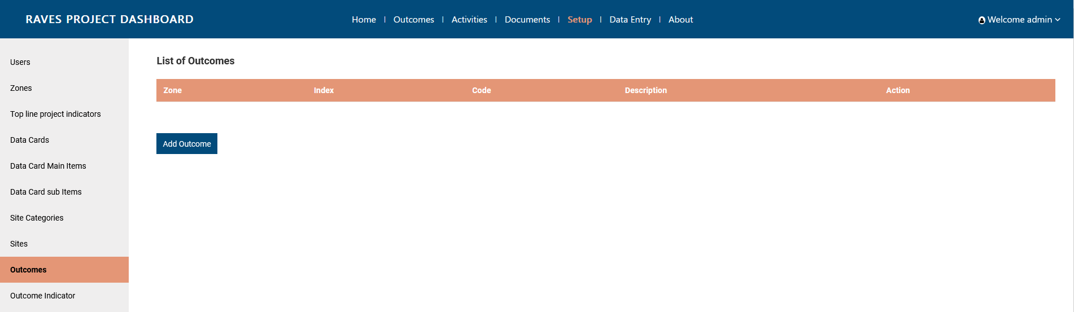

Step 4: Select Zone, fill in further details. Code has to be unique per project. Sort position will decide the position in front end page
Step 5: Click on Submit to proceed
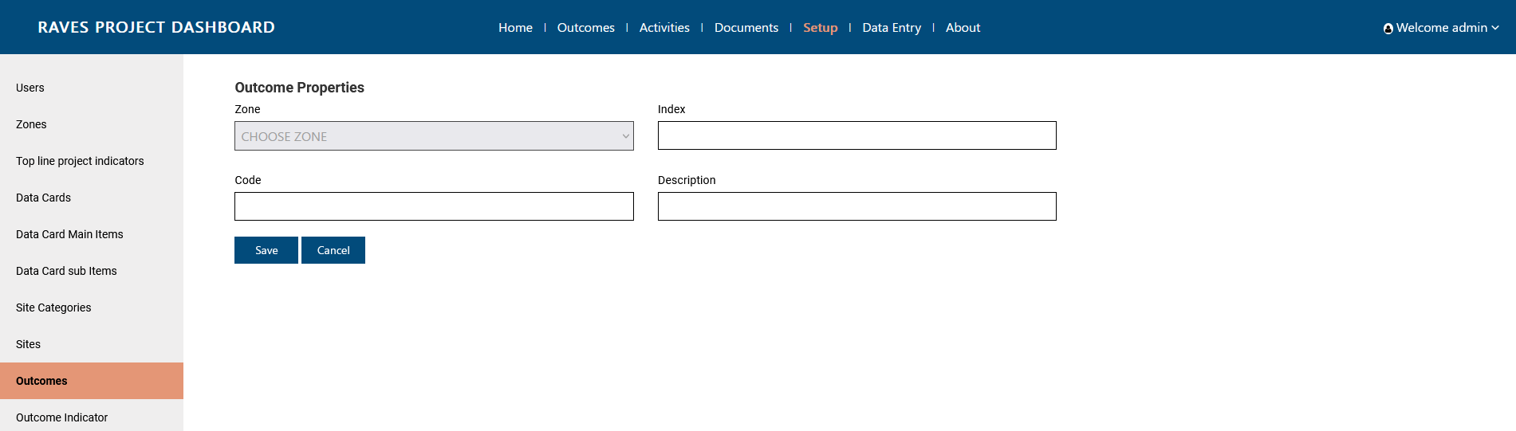

Edit Outcome
Step 1: Click on ‘Setup’ page from header
Step 2: Click on Outcome from left side menu bar
Step 3: Click on edit button against the outcome
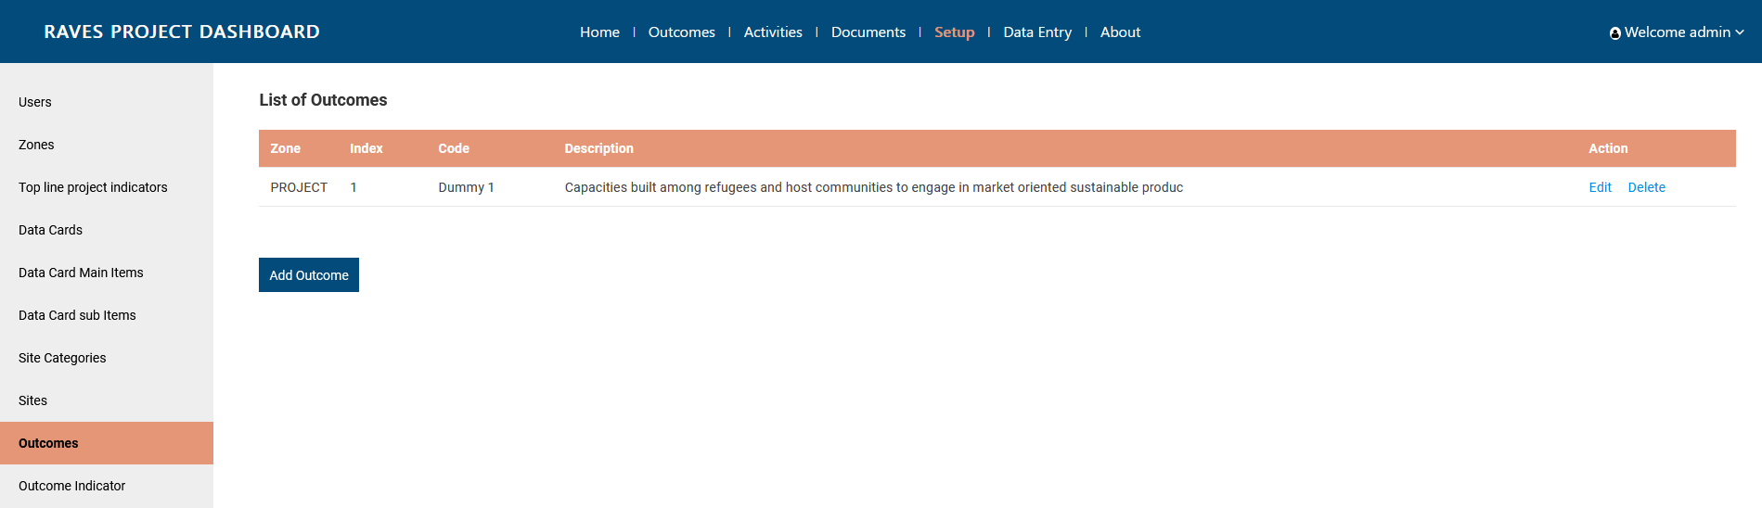

Step 4: Edit details.
Step 5: Click on Update to proceed
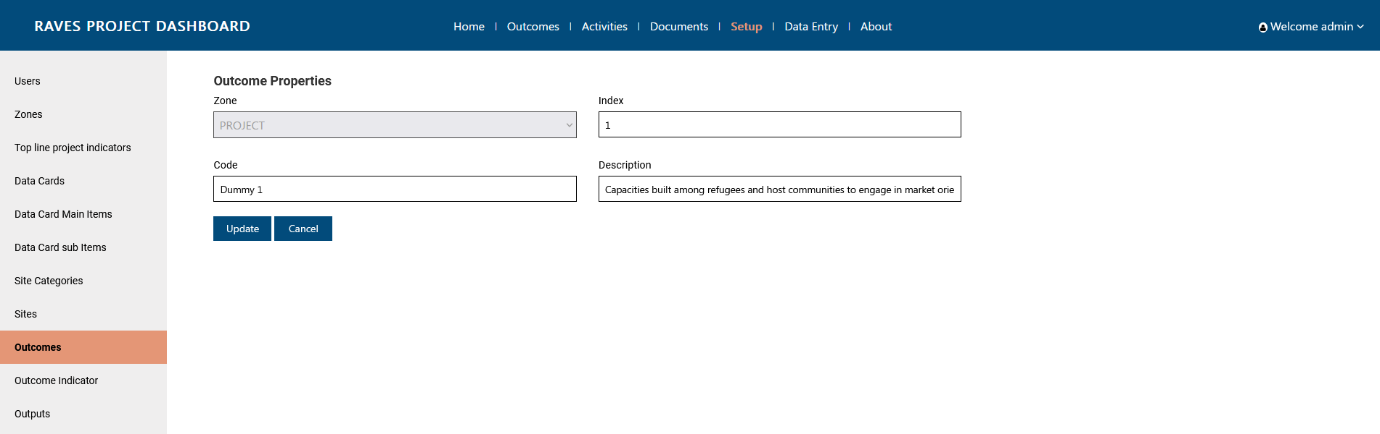

Add Outcome Indicator
Step 1: Click on ‘Setup’ page from header
Step 2: Click on Outcome Indicator from left side menu bar
Step 3: Click on Add Outcome Indicator button .
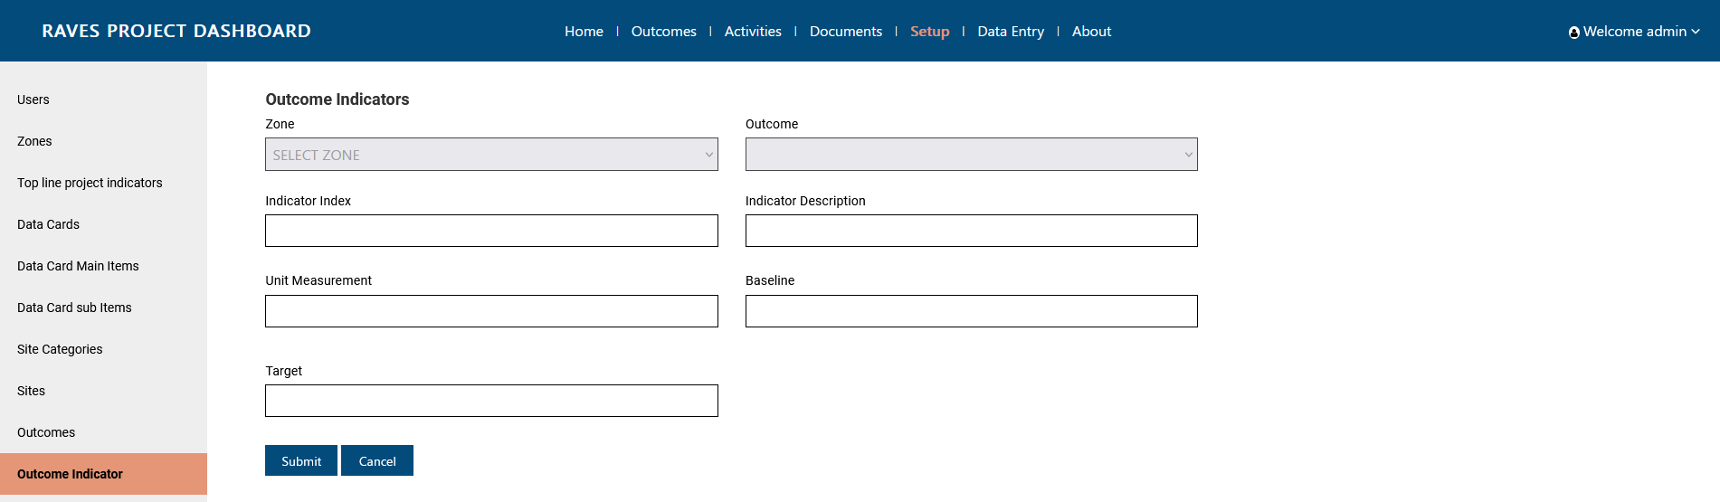

Step 4: Select Zone, to activate Outcome dropdown. Fill in further details. Indicator index has to be unique
Step 5: Click on Submit to proceed

Edit Outcome Indicator
Step 1: Click on ‘Setup’ page from header
Step 2: Click on Outcome Indicator from left side menu bar
Step 3: Click on Add Outcome Indicator button .

Edit Outcome Indicator
Step 1: Click on ‘Setup’ page from header
Step 2: Click on Outcome Indicator from left side menu bar
Step 3: Click on edit button against the outcome
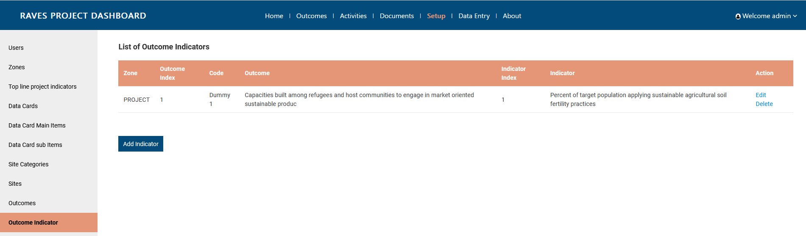

Step 4: Edit details.
Step 5: Click on Update to proceed

Adding Values to Outcome Indicator
Step 1: Click on ‘Data entry’ page from header
Step 2: Click on Outcome Indicators from left side menu bar
Step 3: Click on Add Outcome Indicator Data
Step 4: Fill in the details. Select Zone first to activate the Outcome dropdown. Select Outcome to further activate the Outcome indicator dropdown. Enter the 4 digits year along with the month from dropdown, and add the value.
Step 5: Click on submit to proceed.
Note: For adding new value for another period, add a new data entry.

Edit Outcome indicator values
Step 1: Click on ‘Data entry’ page from header
Step 2: Click on Outcome Indicators from left side menu bar
Step 3: Click on Edit button against the Outcome Indicator
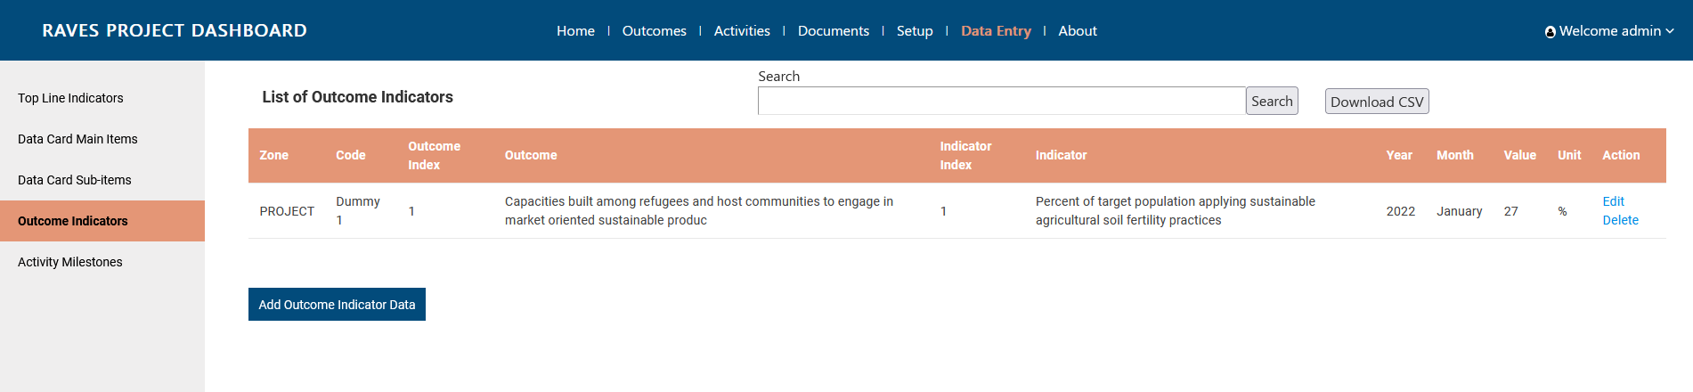
Step 4: Edit details. One can edit value
Step 5: Click on update to proceed.
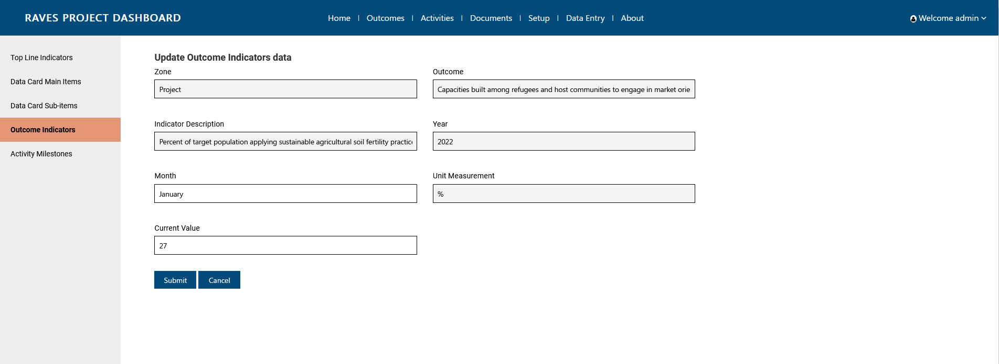

Output and Activities Management

Add Output
Step 1: Click on ‘Setup’ page from header
Step 2: Click on Output from left side menu bar
Step 3: Click on Add Output button .
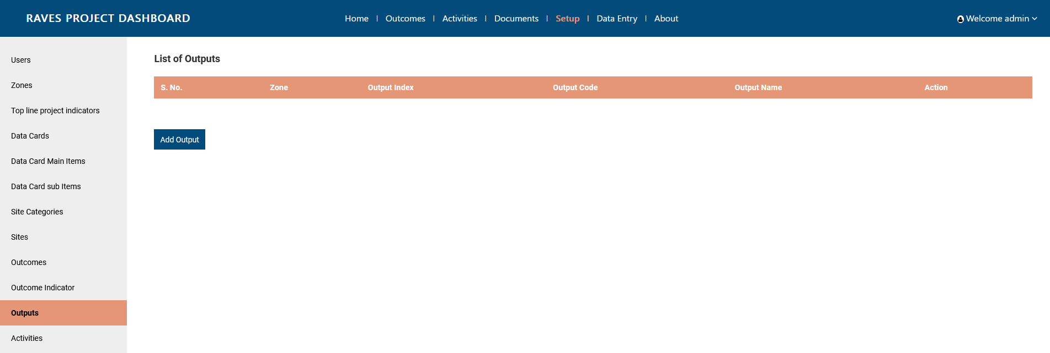

Step 4: Select Zone, fill in further details. Code has to be unique per project. Index will decide the position in front end page
Step 5: Click on Submit to proceed
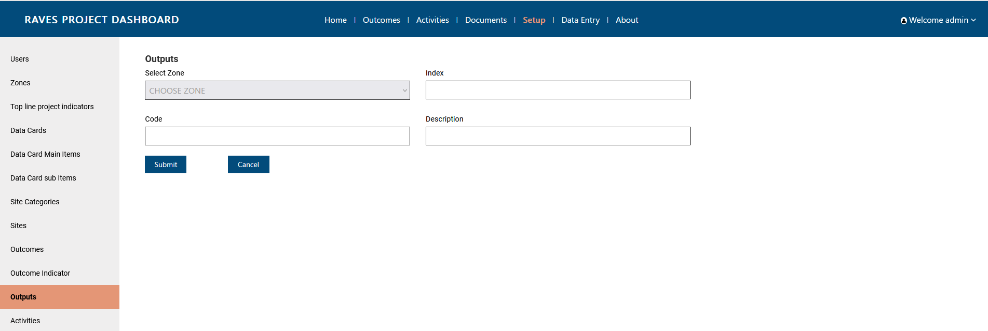

Edit Output
Step 1: Click on ‘Setup’ page from header
Step 2: Click on Output from left side menu bar
Step 3: Click on edit button against the output
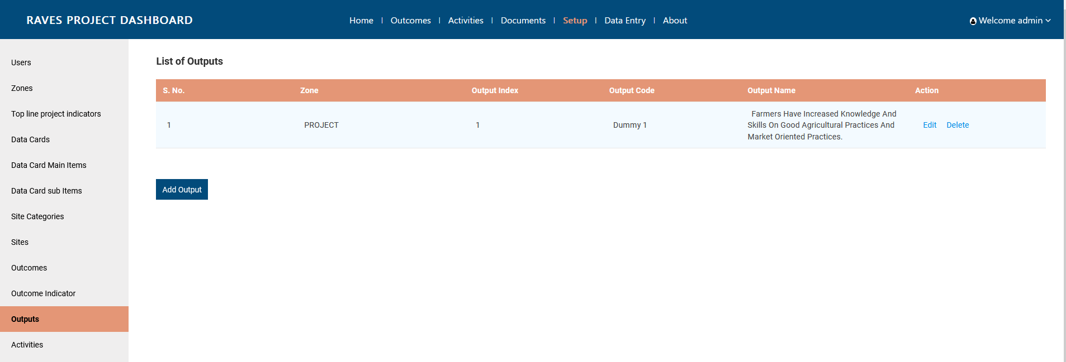

Step 4: Edit details.
Step 5: Click on Update to proceed
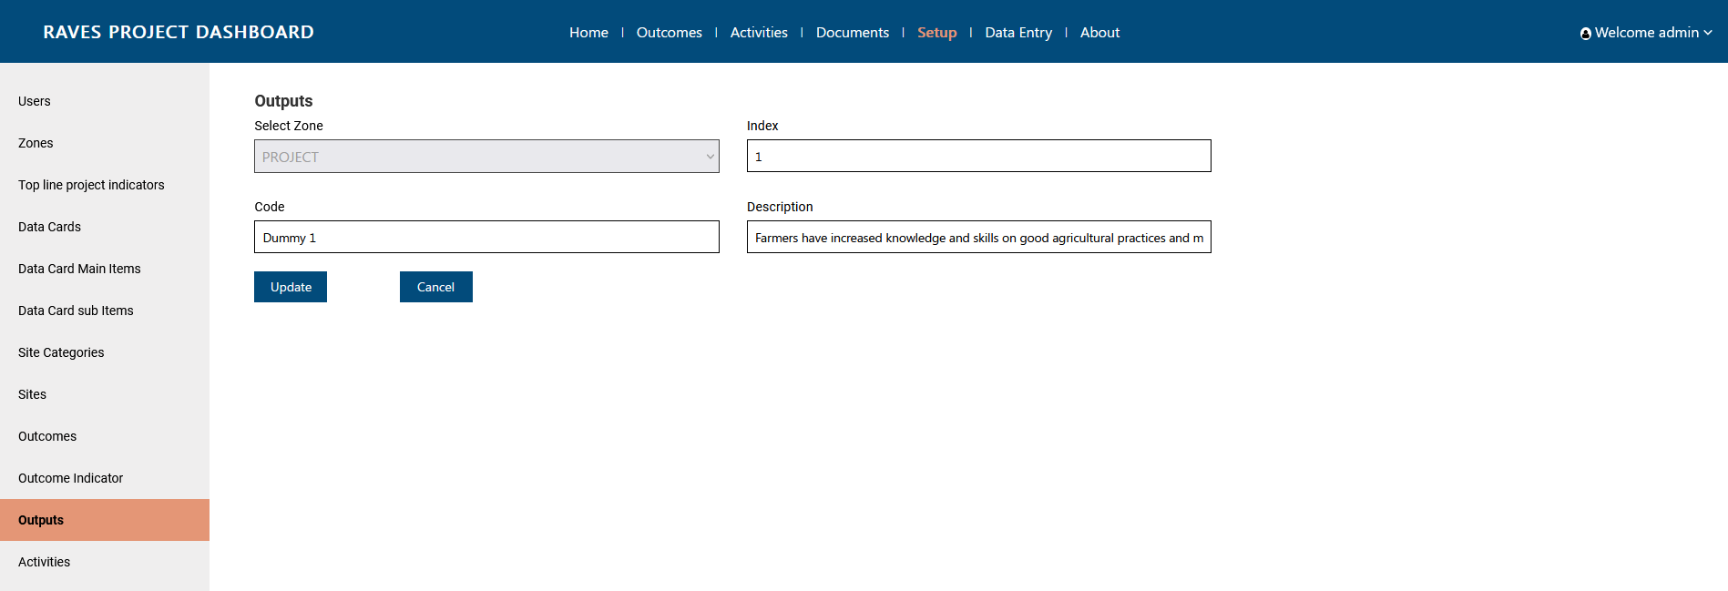

Add Activities
Step 1: Click on ‘Setup’ page from header
Step 2: Click on Activities from left side menu bar
Step 3: Click on Add Activities button .
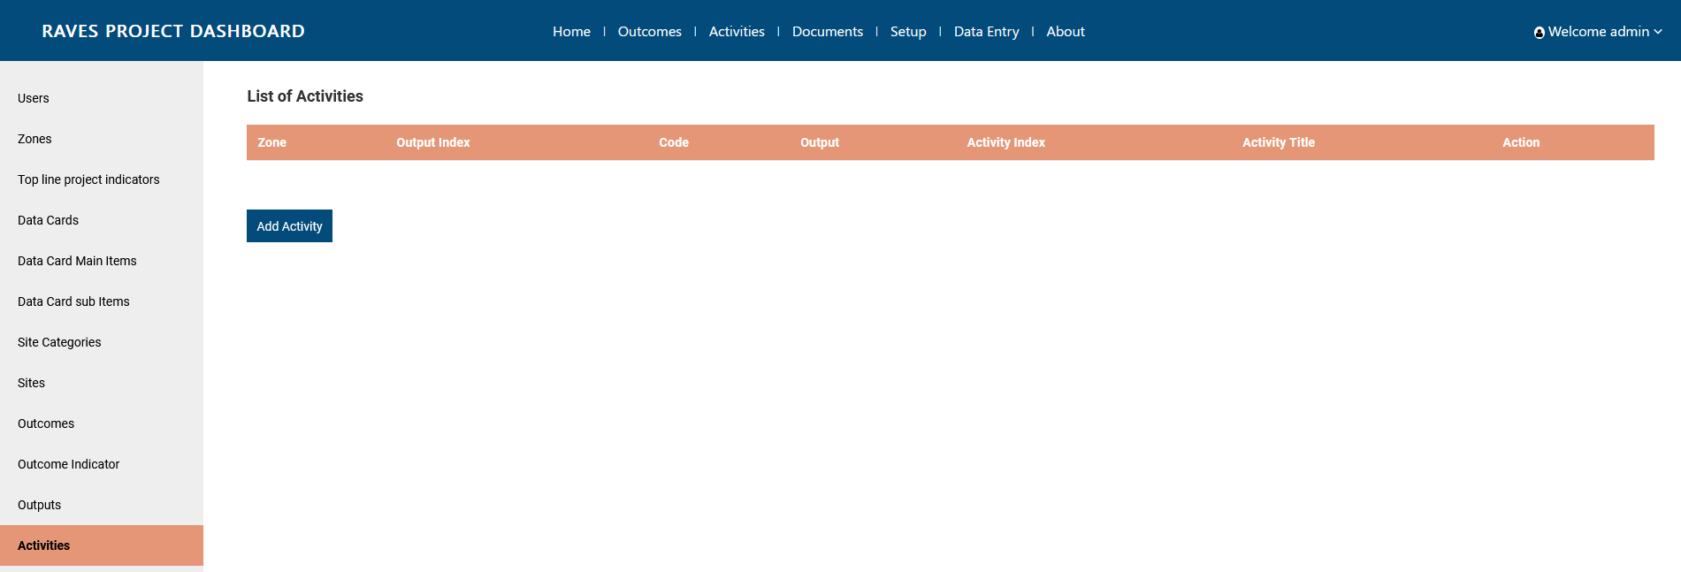

Step 4: Select Zone, to activate Output dropdown. Fill in further details. Activity index has to be unique
Step 5: Click on Submit to proceed
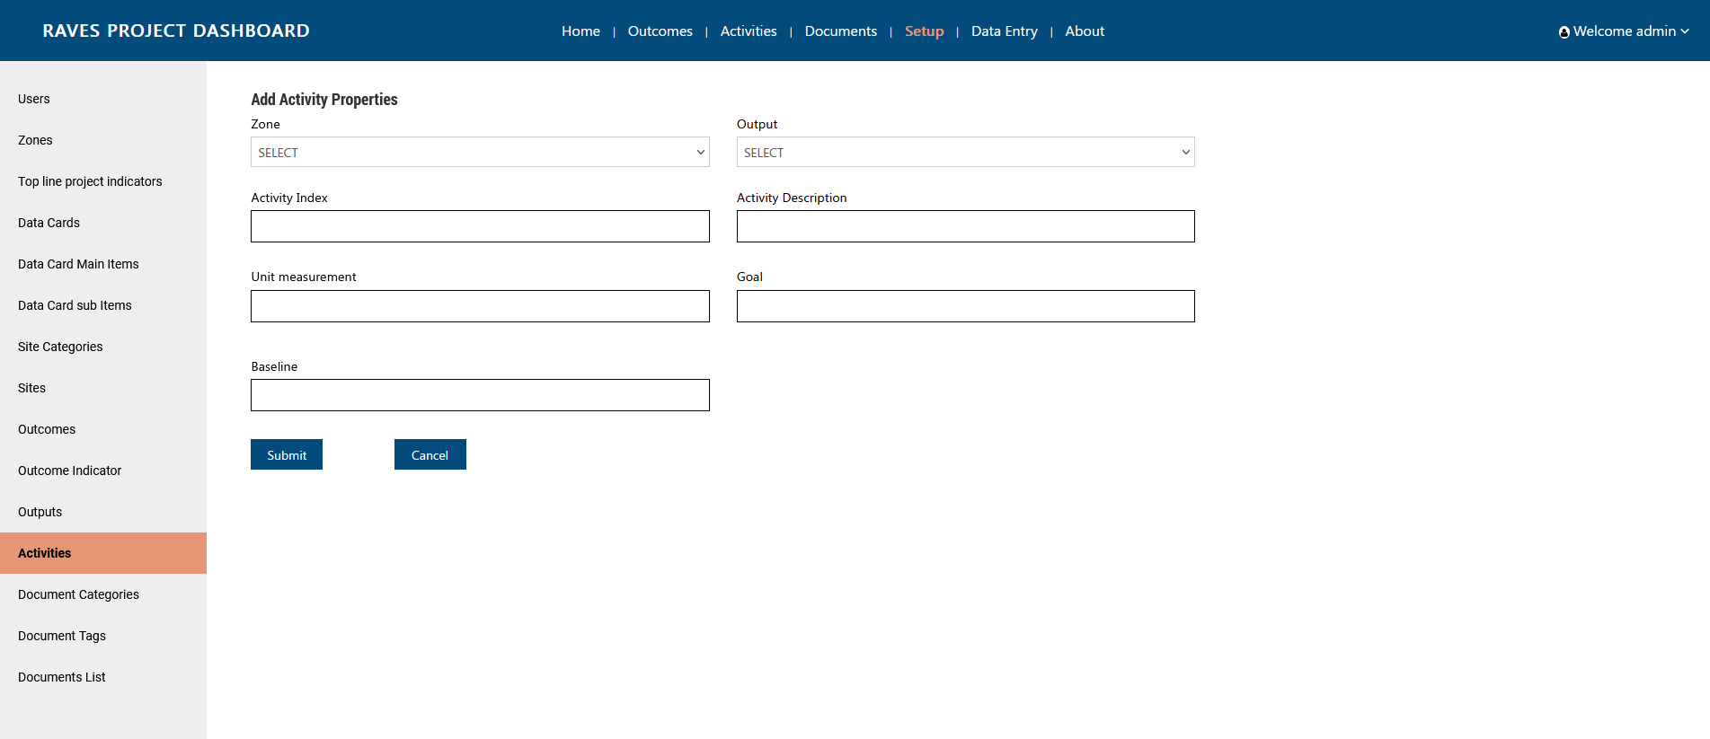

Edit Activities
Step 1: Click on ‘Setup’ page from header
Step 2: Click on Activity from left side menu bar
Step 3: Click on Edit button against the Activity

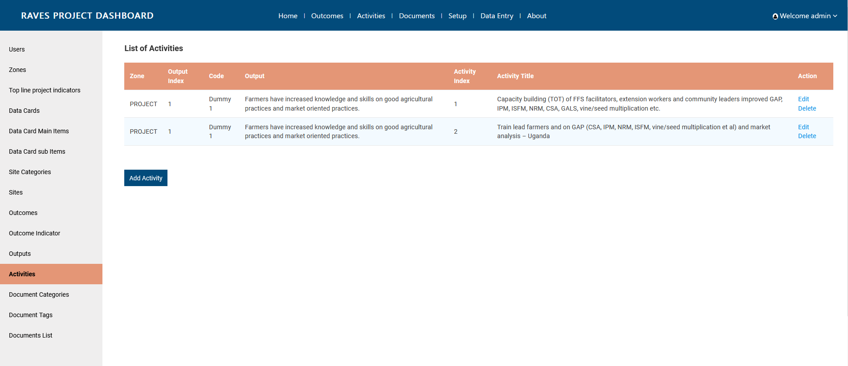
Step 4: Edit details
Step 5: Click on update to proceed.
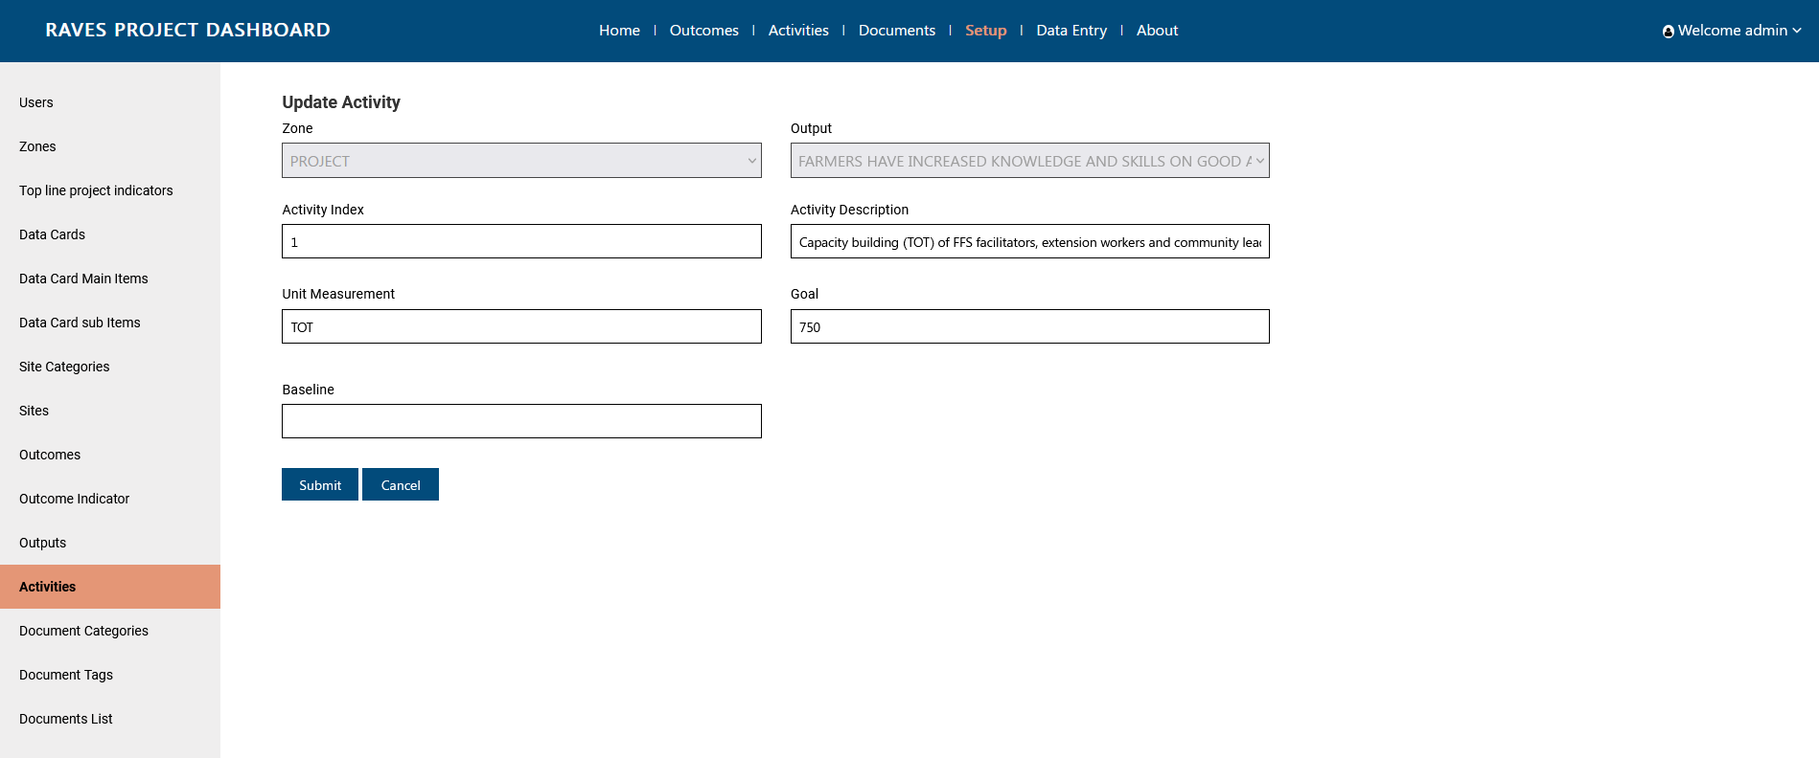

Adding Values to Activities
Step 1: Click on ‘Data entry’ page from header
Step 2: Click on Activity Milestones from left side menu bar
Step 3: Click on Add Activity Data

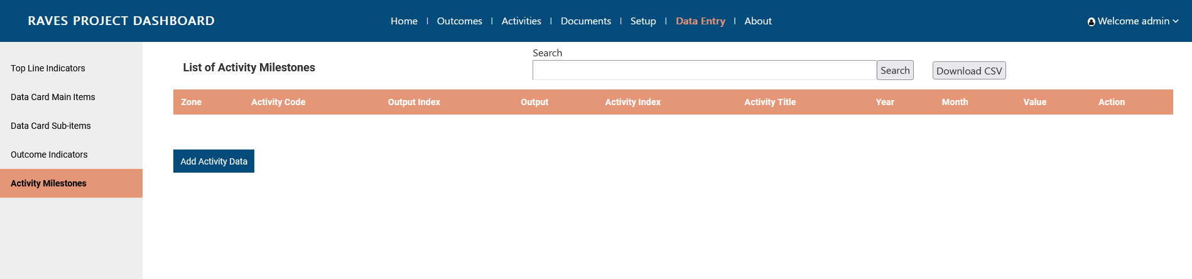
Step 4: Fill in the details. Select Zone first to activate the Output dropdown. Select Output to further activate the Indicator description dropdown. Enter the 4 digits year along with the month from dropdown, and add the value.
Step 5: Click on submit to proceed.
Note: For adding new value for another period, add a new data entry.
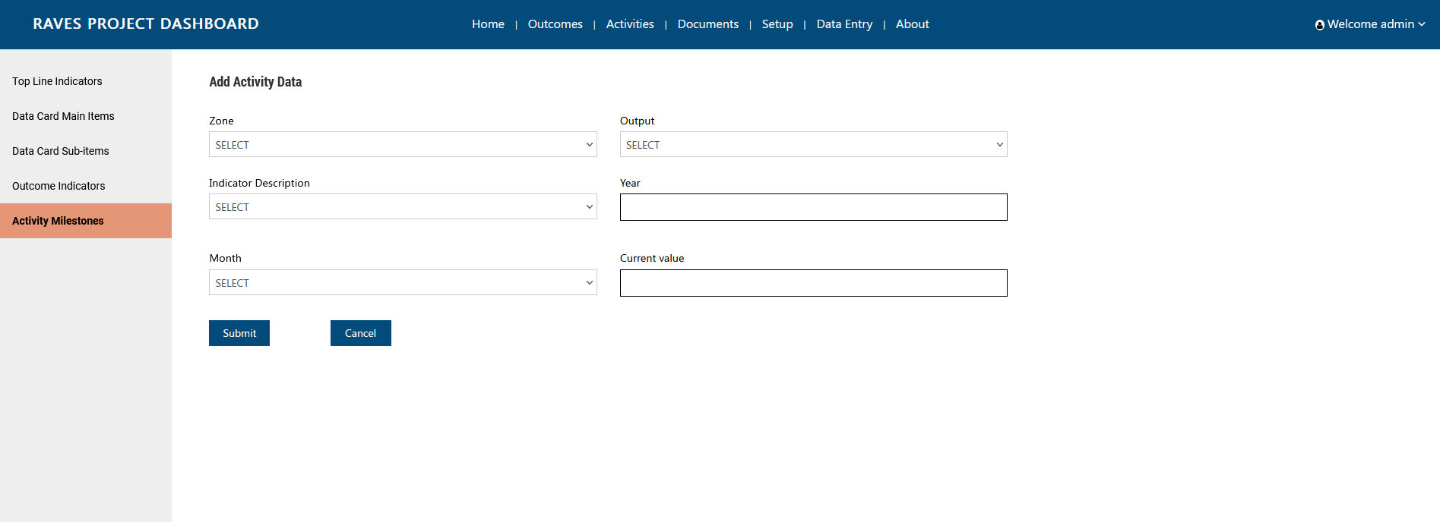

Edit Activity Milestones values
Step 1: Click on ‘Data entry’ page from header
Step 2: Click on Activity Milestones from left side menu bar
Step 3: Click on Edit button against the Activity
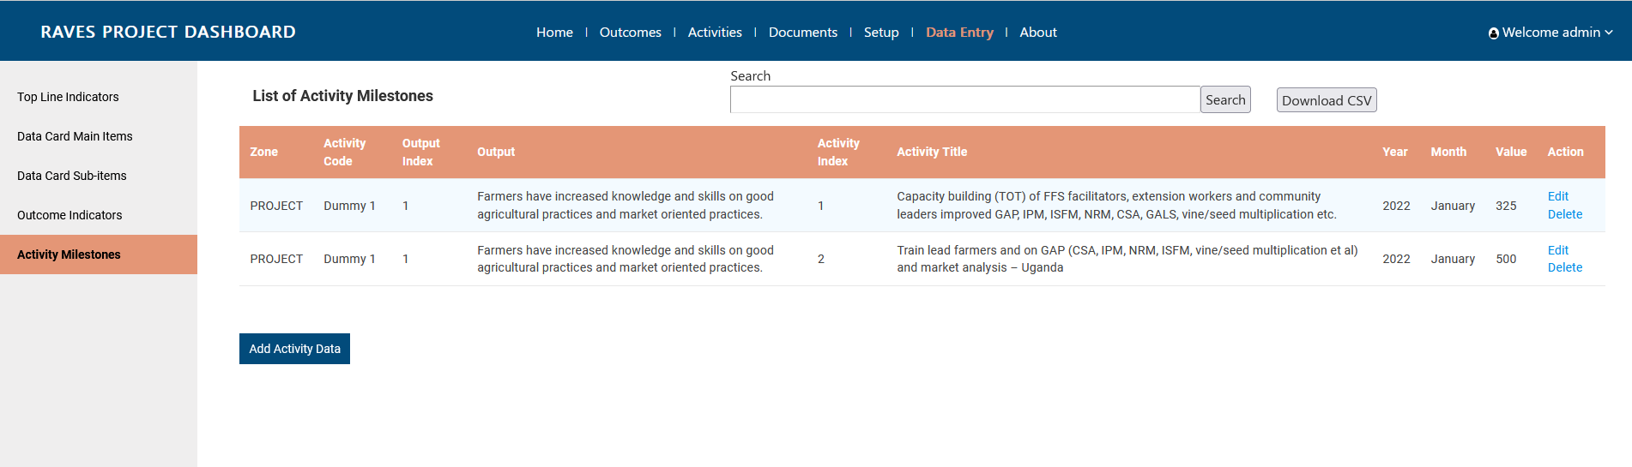
Step 4: Edit details. One can edit value
Step 5: Click on update to proceed.

Documents Management
Before adding the document, do verify if the necessary category and tags are there in the system. Documents are of 2 types, Public (Visible to all) and Private(Visible to only persons with authorised access.)

Add Document Categories
Step 1: Click on ‘Setup’ page from header
Step 2: Click on Document Categories from left side menu bar
Step 3: Click on Add categories button .
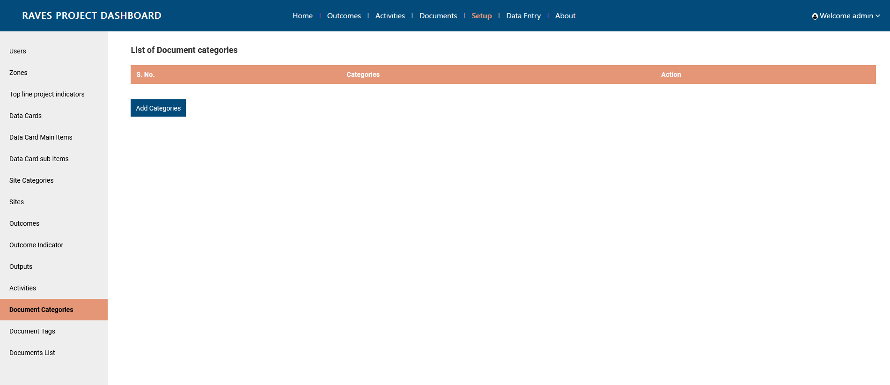

Step 4: Enter description and upload the icon
Step 5: Click on Submit to proceed

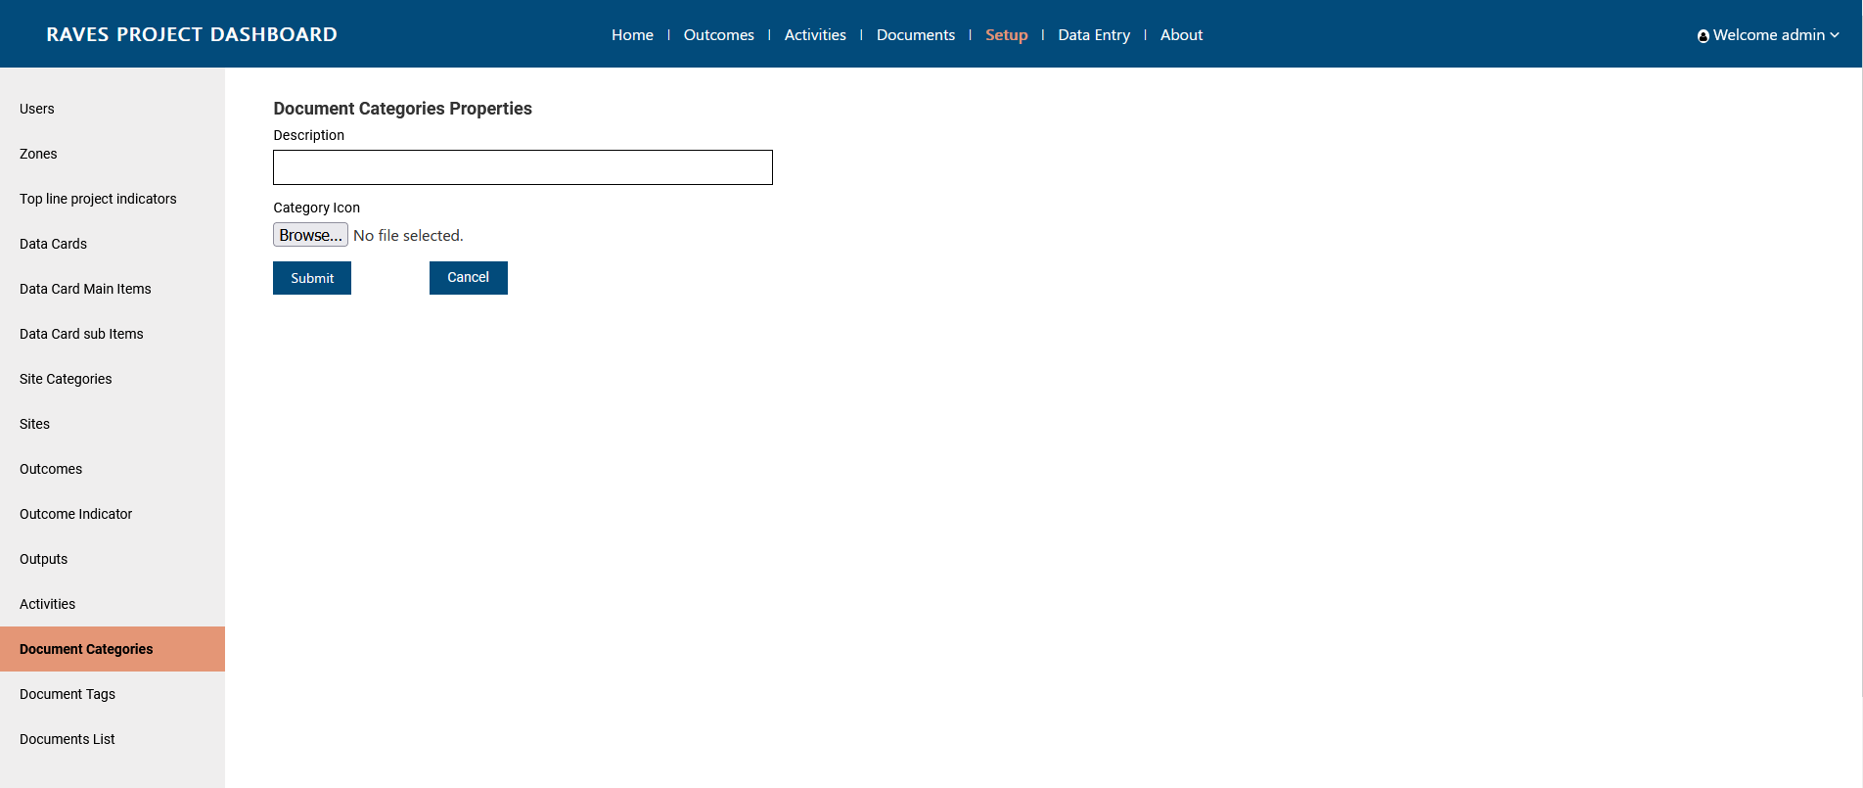

Edit Document Categories
Step 1: Click on ‘Setup’ page from header
Step 2: Click on Document Categories from left side menu bar
Step 3: Click on Edit button against the category
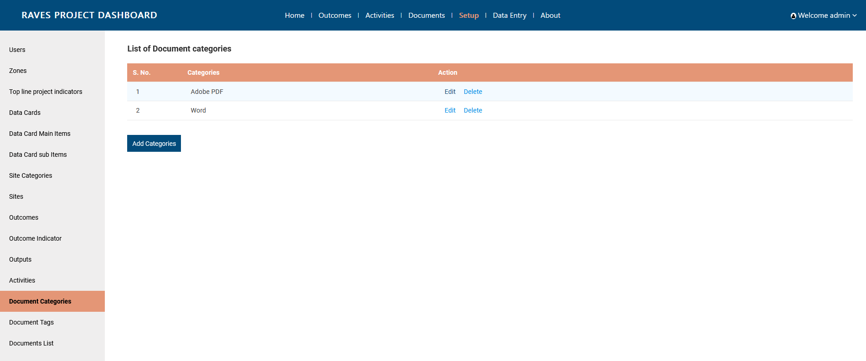
Step 4: Edit details
Step 5: Click on update to proceed.

Add Document Tags
Step 1: Click on ‘Setup’ page from header
Step 2: Click on Document Tags from left side menu bar
Step 3: Click on Add Tags button .
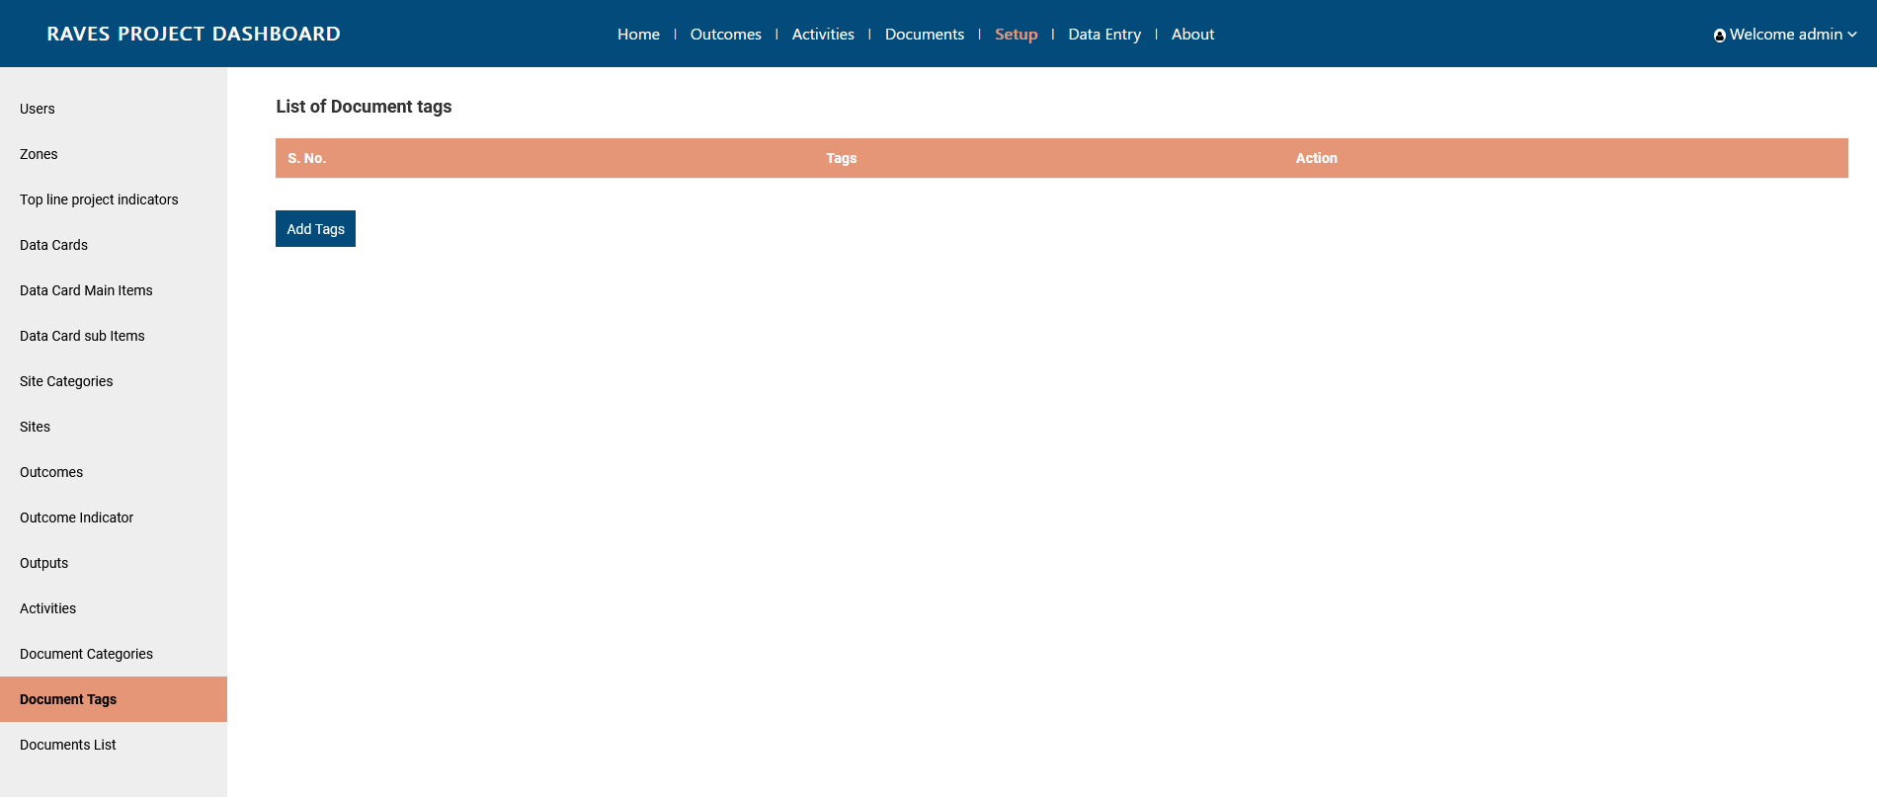

Step 4: Enter description
Step 5: Click on submit to proceed
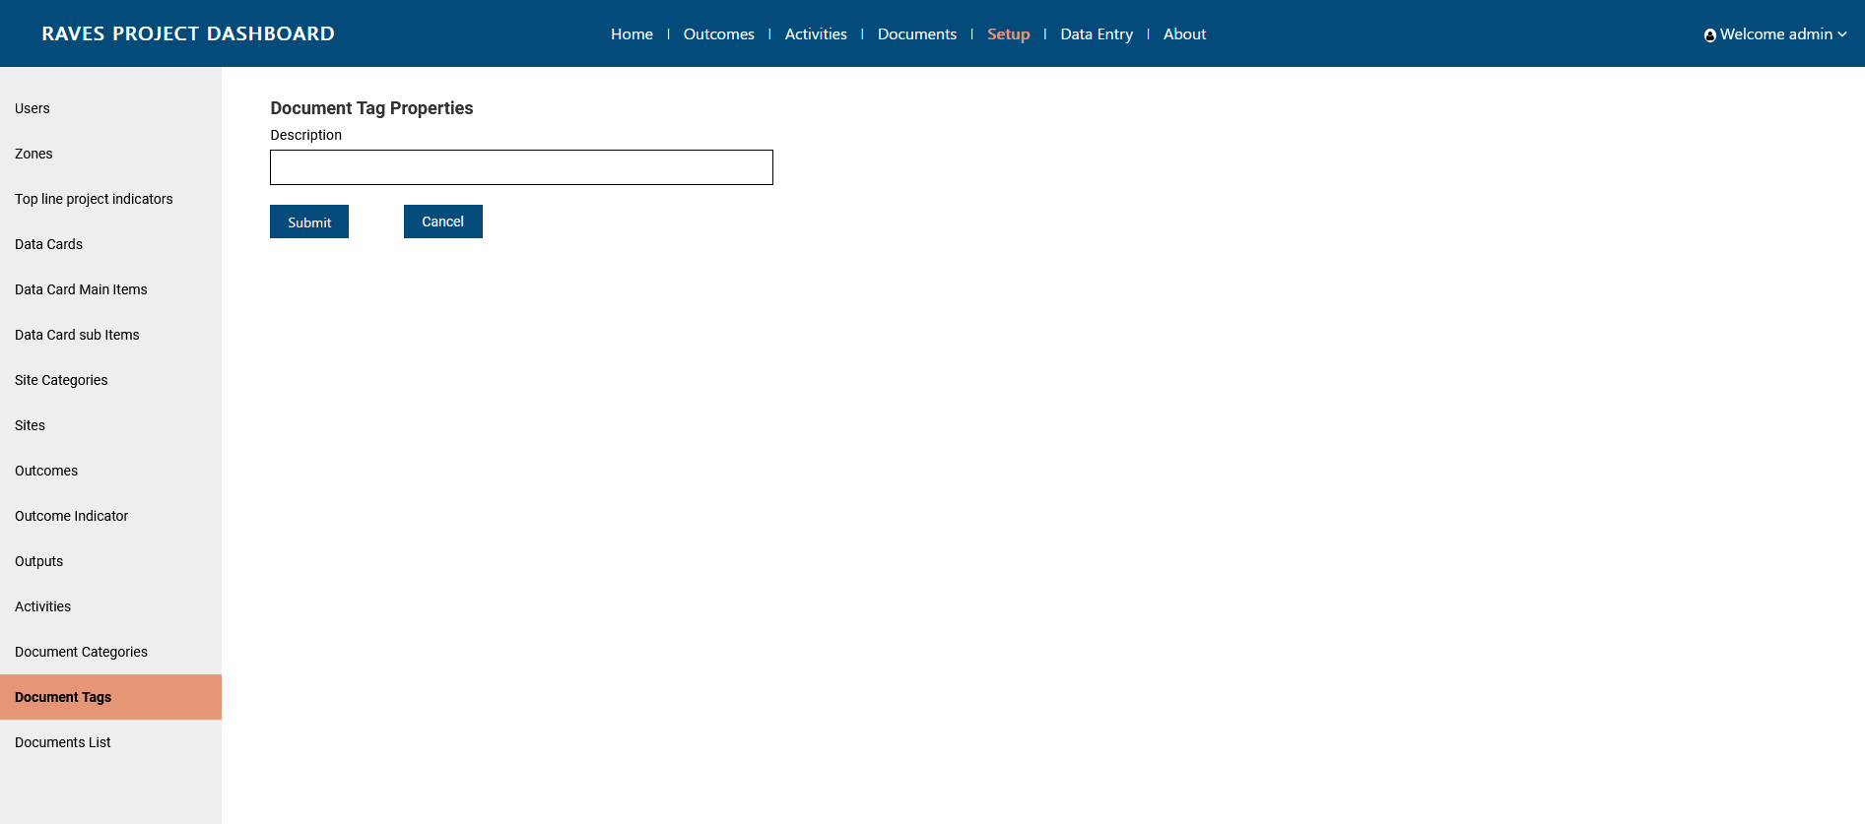

Edit Document Tags
Step 1: Click on ‘Setup’ page from header
Step 2: Click on Document Tags from left side menu bar
Step 3: Click on Edit button against the Tag
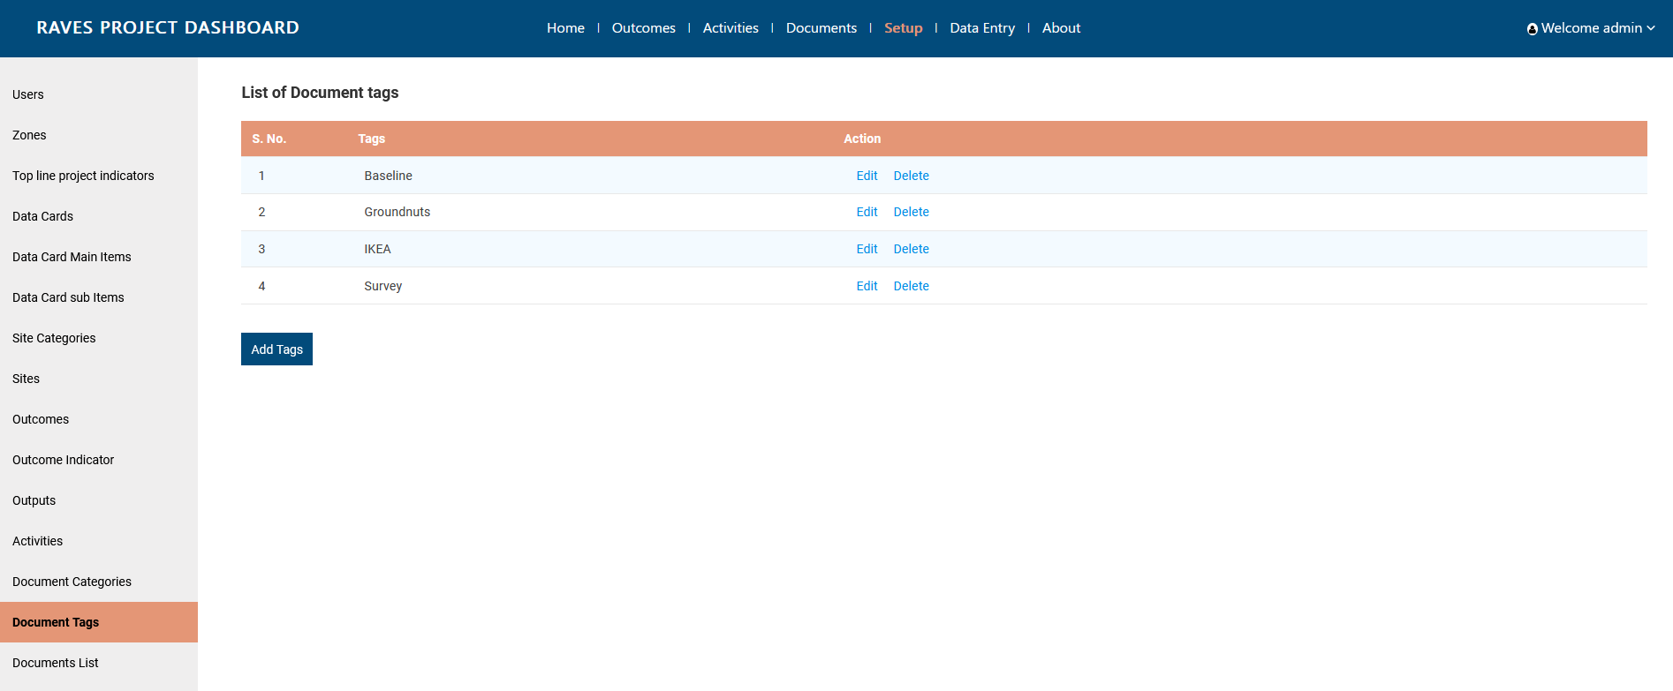
Step 4: Edit description
Step 5: Click on update to proceed.
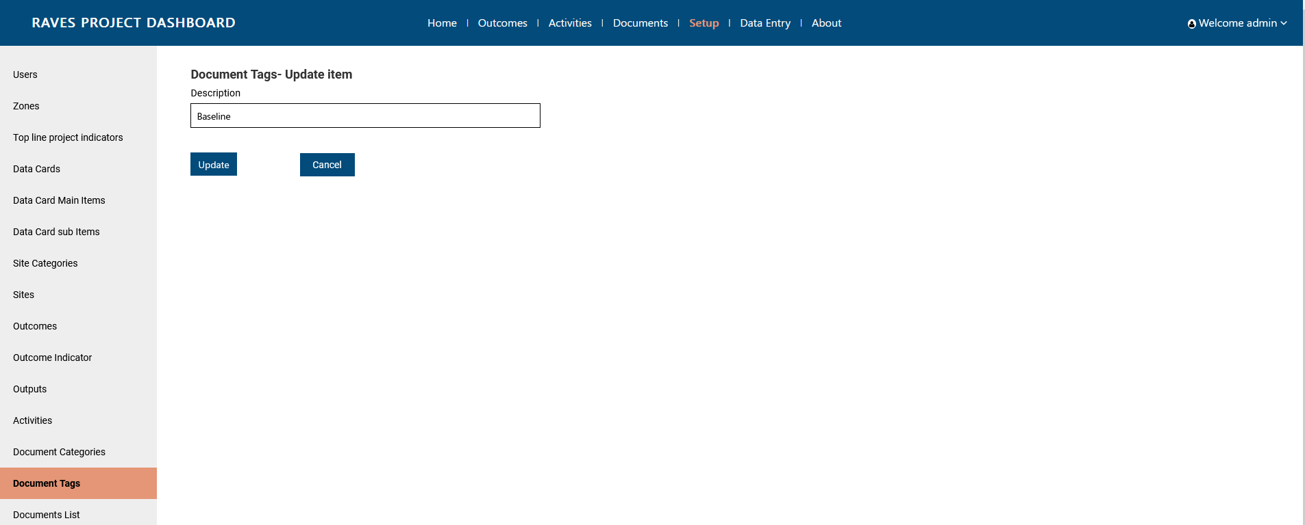

Add Documents
Step 1: Click on ‘Setup’ page from header
Step 2: Click on Document List from left side menu bar
Step 3: Click on Add Documents button .
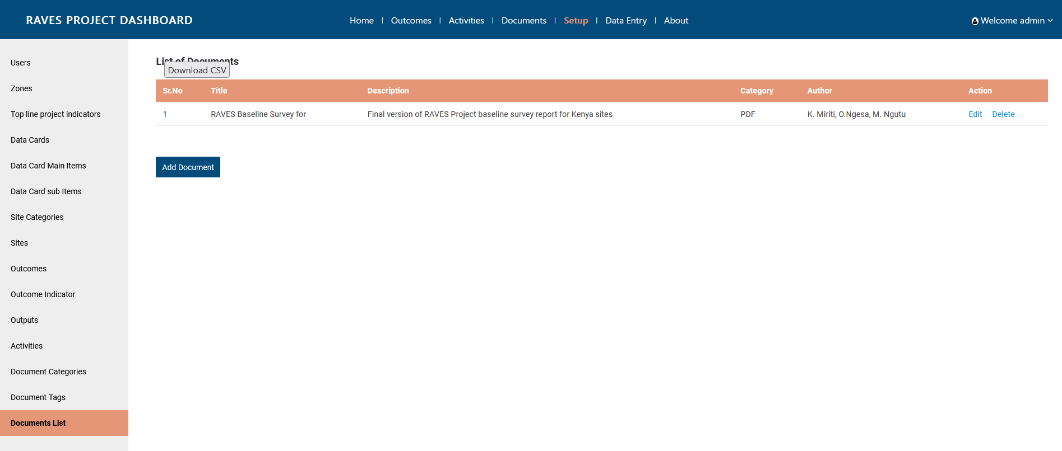
Step 4: Fill in the details and upload document
Step 5: Click on submit to proceed.
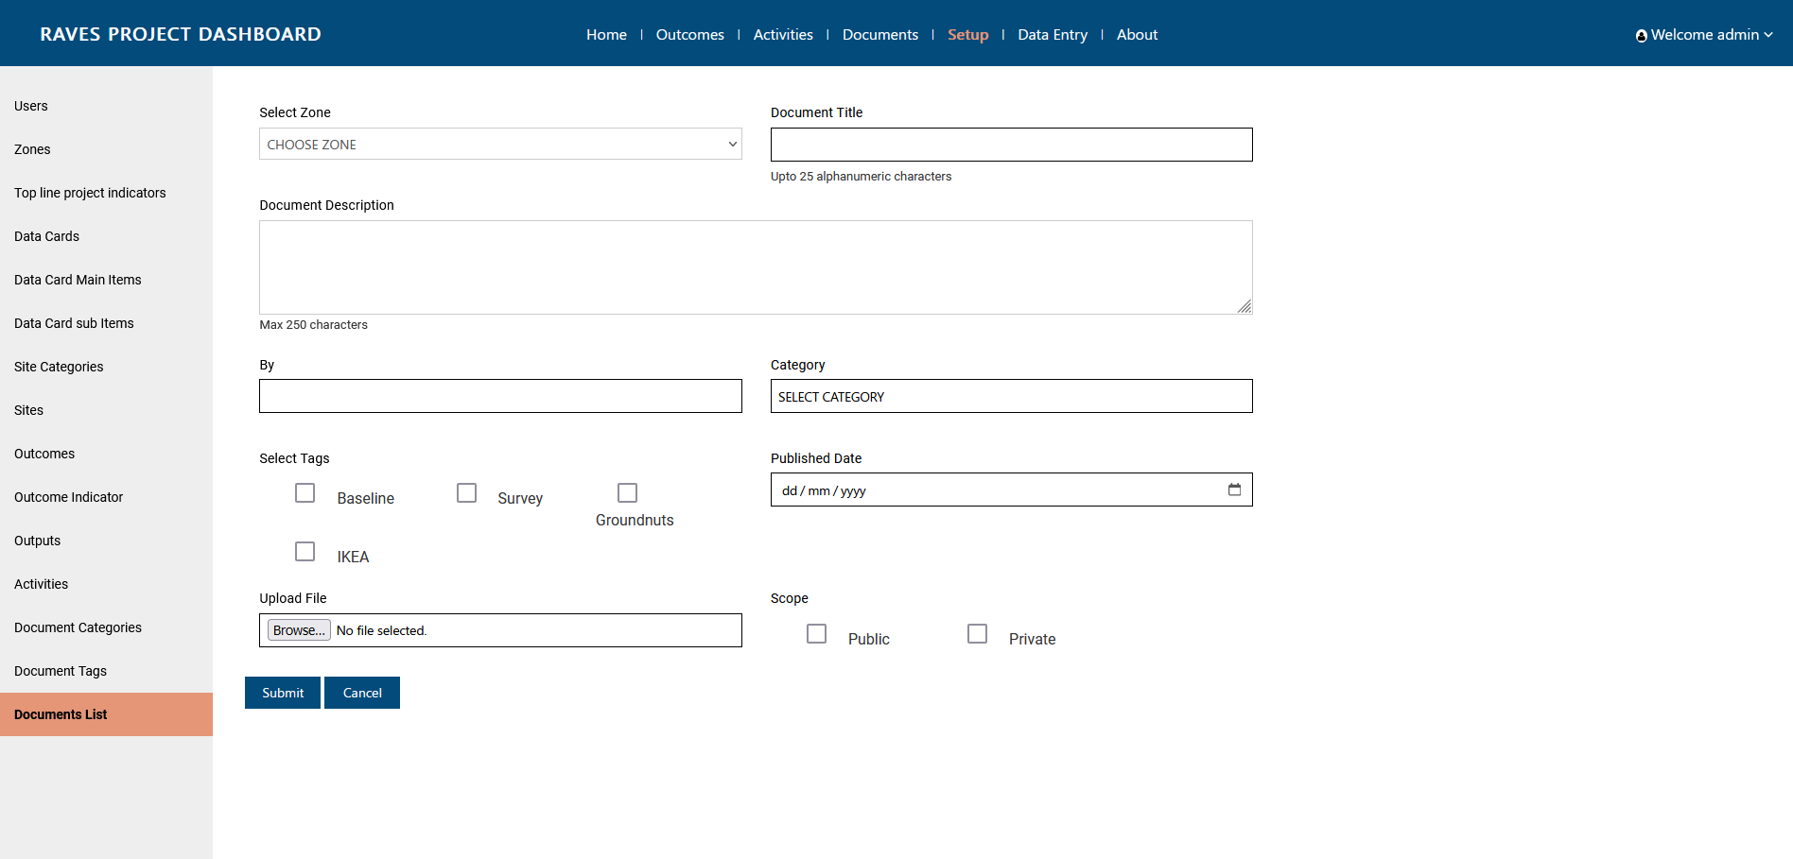

Edit Documents
Step 1: Click on ‘Setup’ page from header
Step 2: Click on Document List from left side menu bar
Step 3: Click on Edit button against the document.
Step 4: Edit in the details
Step 5: Click on Update to proceed.
